CE100 Lab Report 4

Counter

Justin Fortner

Lab 1C

TU/TH 1:30-3:20

11/9/17

**Description:**

In this lab several different counters were built and implemented in order to create a 16 bit counter. This 16 bit counter is comprised of one 5 bit counter, two 4 bit counters and one three bit counter. These counters are loadable and are capable of counting from 0000 to FFFF. A ring counter, selector and hex7seg allow the counters to be properly displayed on the 4 sections of the display.

**Methods:**

**Part 1 - Counter:**

count3L: The count3L module is a 3 bit counter consisting of 3 D Flip-Flops. These flip flops are able to count from 0 to 7 as well as be loaded with any value within that range. The counting is only allowed when the count enable is high. When the counter reaches 111 a signal is given out that indicates that the counter has reached its maximum value. The logic for the inputs of the flip flops was obtained by creating a state table. From the state table minimum SOP equations were obtained through the use of K-Maps.

count4L: The count4L module is a 4 bit counter consisting of 4 D Flip-Flops. These flip flops are able to count from 0 to 15 as well as be loaded with any value within that range. The counting is only allowed when the count enable is high. When the counter reaches 1111 a signal is given out that indicates that the counter has reached its maximum value. The logic for the inputs of the flip flops was obtained by creating a state table. From the state table minimum SOP equations were obtained through the use of K-Maps.

count5L: The count5L module is a 4 bit counter consisting of 5 D Flip-Flops. These flip flops are able to count from 0 to 31 as well as be loaded with any value within that range. The counting is only allowed when the count enable is high. When the counter reaches 11111 a signal is given out that indicates that the counter has reached its maximum value. The logic for the inputs of the flip flops was obtained by creating a state table. From the state table minimum SOP equations were obtained through the use of K-Maps.

count16L: The count 16L module consists of one 3 bit counter, two 4 bit counters and one 5 bit counter. These counters are connected together. The count3L will count first. Once this counter has reached its maximum value if then activates the first count 4L. Once this had reached its maximum value the second count4L is activated. Lastly when this count4L has reached its maximum value the count5L is activated. This gives us a 16 bit counter capable of counting from 0 to 65535. When this counter reaches its maximum value a signal is given out to indicate such.

**Part 2 - Selector:**

The selector chooses which of the four display segments to activate. It achieves this by taking in a one four bit input. When one of these bits is high return which segment of the counter output to display. This is accomplished by sign extending each individual selector bit and ANDing it with their appropriate counter outputs.

**Part 3 - Ring Counter:**

The ring counter advances a 1 through four D flip flops. The ring counter is the selector input for the selector. The ring counter is completed by initializing the first register with a 1 and then passing this one to the next register and setting the previous one to 0.

**Part 4 - Edge Detector:**

The edge detector consists of two flip flops. The input to the first flip flop is button C. The input to the second flip flop is the output of the first. If the output of both flip flops is 0 and then button C is pressed then a high value is generated.

**Part 5 - Top Level:**

The top level schematic ties together all previous elements of the lab. They are connected together just as indicated in the diagram in the lab manual. Also within this module is logic for the 4 segments of the hex7seg , dp and the mystery box.

Mystery Box: The mystery box stops the counter when it reaches FFFC and allows the timer to begin being incremented by 1.

**Results:**

**Design:**

**Top Level:**

The top level design provides the input from the OR value of the clock stopper and the edge detector. This is used as the count16L count enable. The top level also provides the load enable and the values from the switches that can be loaded into the counter. The output for dp and the 4 segments of the display are also in here.

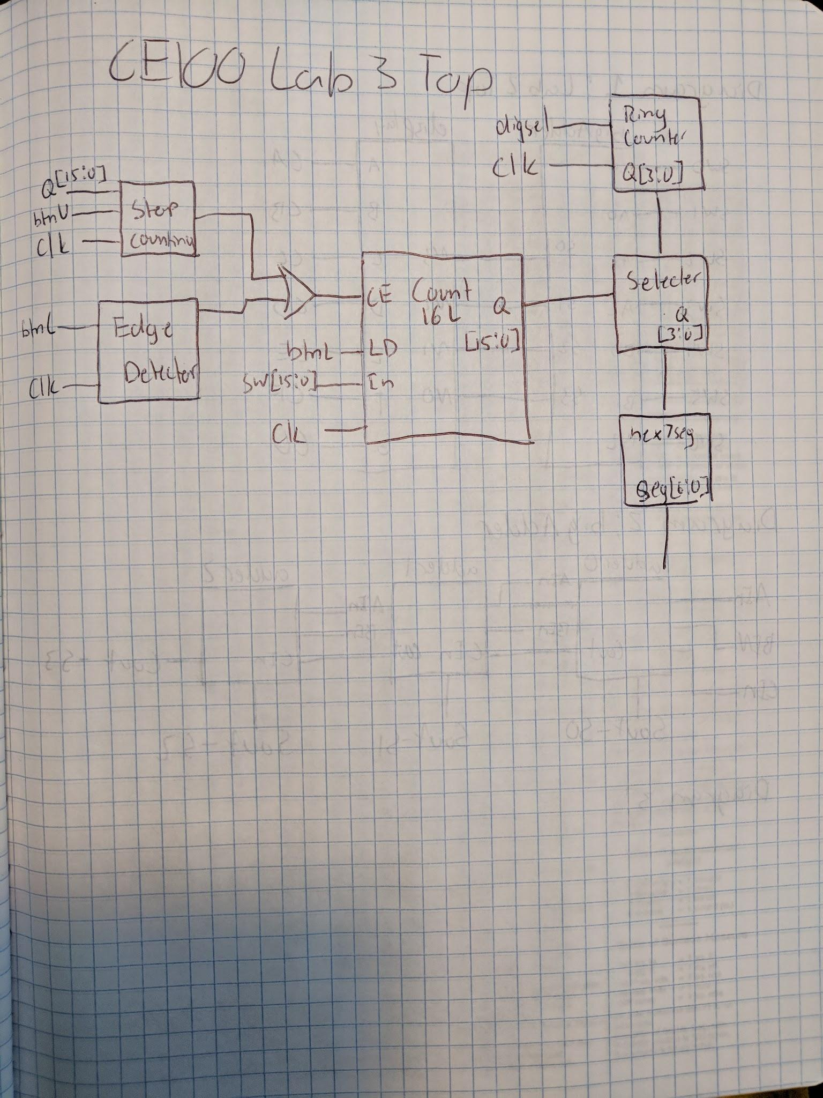

wORIn = (wCount16LOut[15]&wCount16LOut[14]&wCount16LOut[13]&wCount16LOut[12]&wCount16LOut[11]&wCount16LOut[10]&wCount16LOut[9]&wCount16LOut[8]&wCount16LOut[7]&wCount16LOut[6]&wCount16LOut[5]&wCount16LOut[4]&wCount16LOut[3]&wCount16LOut[2])&((~wCount16LOut[0]&~wCount16LOut[1])|(wCount16LOut[0]&~wCount16LOut[1])|(~wCount16LOut[0]&wCount16LOut[1])|(wCount16LOut[0]&wCount16LOut[1]));

wOROut = wEdgeOut|(btnU&~wORIn);

**Edge Detector:**

The edge detector design consists of two flip flops and one logic statement. If both flip flops are zero and btnC is pressed then a high signal is produced.

edgeOut = btnC&wQ[0]&~wQ[1];

**Ring Counter:**

The ring counter consists of four flip flops. One of these flip flops is initialized to 1. The flip flops are connected in series. With the output of the last flip flop connected into the input of the first. This allows the output to rotate between 1000, 0100, 0010, 0001 and back to 1000.

**Selector:**

The selector chooses which of the four segments the output of the count16L is passed along to the hex7seg module. This is accomplished by a selector input provided by the ring counter. Each bit of this input is extended to be 4 bits long. Each new group of 4 is then ANDed with 4 inputs from the count16L. 4 bits of the 16 bit input will be passed along.

H = (extend3&N[15:12]) | (extend2&N[11:8]) | (extend1&N[7:4]) | (extend0&N[3:0]);

**Hex7Seg:**

The hex7seg takes the output of the ripple carry adder and converts it into a hex value that can be displayed on the board. The 7 segment display is made up of 7 8 to 1 multiplexers. Each one is responsible for one of the 7 segments in each unit. The inputs for the multiplexers is derived from K-maps filled with values from the truth table.

|  |  |  |  |  |  |  |  |  |  |  |  |
| --- | --- | --- | --- | --- | --- | --- | --- | --- | --- | --- | --- |
| # | n3 | n2 | n1 | n0 | A | B | C | D | E | F | G |
| 0 | 0 | 0 | 0 | 0 | 1 | 1 | 1 | 1 | 1 | 1 | 0 |
| 1 | 0 | 0 | 0 | 1 | 0 | 1 | 1 | 0 | 0 | 0 | 0 |
| 2 | 0 | 0 | 1 | 0 | 1 | 1 | 0 | 1 | 1 | 0 | 1 |
| 3 | 0 | 0 | 1 | 1 | 1 | 1 | 1 | 1 | 0 | 0 | 1 |
| 4 | 0 | 1 | 0 | 0 | 0 | 1 | 1 | 0 | 0 | 1 | 1 |
| 5 | 0 | 1 | 0 | 1 | 1 | 0 | 1 | 1 | 0 | 1 | 1 |
| 6 | 0 | 1 | 1 | 0 | 1 | 0 | 1 | 1 | 1 | 1 | 1 |
| 7 | 0 | 1 | 1 | 1 | 1 | 1 | 1 | 0 | 0 | 0 | 0 |
| 8 | 1 | 0 | 0 | 0 | 1 | 1 | 1 | 1 | 1 | 1 | 1 |
| 9 | 1 | 0 | 0 | 1 | 1 | 1 | 1 | 0 | 0 | 1 | 1 |
| A | 1 | 0 | 1 | 0 | 1 | 1 | 1 | 0 | 0 | 1 | 1 |
| B | 1 | 0 | 1 | 1 | 1 | 1 | 1 | 0 | 1 | 1 | 1 |
| C | 1 | 1 | 0 | 0 | 0 | 0 | 1 | 1 | 1 | 1 | 1 |
| D | 1 | 1 | 0 | 1 | 0 | 1 | 1 | 1 | 1 | 0 | 1 |
| E | 1 | 1 | 1 | 0 | 1 | 0 | 0 | 1 | 1 | 1 | 1 |
| F | 1 | 1 | 1 | 1 | 1 | 0 | 0 | 0 | 1 | 1 | 1 |

K-Map Results

A

1'b0, 1'b1, 1'b0, 1'b0, 1'b0, ~n[0], 1'b0, n[0]

B

1'b1, ~n[0], 1'b0, 1'b0, ~n[0], n[0], 1'b0, 1'b0

C

1'b1, 1'b0, 1'b0, 1'b0, 1'b0, 1'b0, ~n[0], 1'b0

D

n[0], 1'b0, 1'b1, n[0], n[0], ~n[0], 1'b0, n[0]

E

1'b0, 1'b0, ~n[0], n[0], n[0], 1'b1, n[0], n[0]

F

1'b0, n[0], 1'b0, 1'b0, n[0], 1'b0, 1'b1, n[0]

G

1'b0, 1'b0, 1'b0, 1'b0, n[0], 1'b0, 1'b0, 1'b1

**m8_1e:**

The 8 to 1 multiplexer is made up of the SOP equations derived from the following truth table.

|  |  |  |  |  |  |  |  |  |  |  |  |  |
| --- | --- | --- | --- | --- | --- | --- | --- | --- | --- | --- | --- | --- |
| sel2 | sel1 | sel0 | in7 | in6 | in5 | in4 | in3 | in2 | in1 | in0 | e | o |
| 0 | 0 | 0 | 0 | 0 | 0 | 0 | 0 | 0 | 0 | 1 | 0 | 0 |
| 0 | 0 | 1 | 0 | 0 | 0 | 0 | 0 | 0 | 1 | 0 | 0 | 0 |
| 0 | 1 | 0 | 0 | 0 | 0 | 0 | 0 | 1 | 0 | 0 | 0 | 0 |
| 0 | 1 | 1 | 0 | 0 | 0 | 0 | 1 | 0 | 0 | 0 | 0 | 0 |
| 1 | 0 | 0 | 0 | 0 | 0 | 1 | 0 | 0 | 0 | 0 | 0 | 0 |
| 1 | 0 | 1 | 0 | 0 | 1 | 0 | 0 | 0 | 0 | 0 | 0 | 0 |
| 1 | 1 | 0 | 0 | 1 | 0 | 0 | 0 | 0 | 0 | 0 | 0 | 0 |
| 1 | 1 | 1 | 1 | 0 | 0 | 0 | 0 | 0 | 0 | 0 | 0 | 0 |
| 0 | 0 | 0 | 0 | 0 | 0 | 0 | 0 | 0 | 0 | 1 | 1 | in0 |
| 0 | 0 | 1 | 0 | 0 | 0 | 0 | 0 | 0 | 1 | 0 | 1 | in1 |
| 0 | 1 | 0 | 0 | 0 | 0 | 0 | 0 | 1 | 0 | 0 | 1 | in2 |
| 0 | 1 | 1 | 0 | 0 | 0 | 0 | 1 | 0 | 0 | 0 | 1 | in3 |
| 1 | 0 | 0 | 0 | 0 | 0 | 1 | 0 | 0 | 0 | 0 | 1 | in4 |
| 1 | 0 | 1 | 0 | 0 | 1 | 0 | 0 | 0 | 0 | 0 | 1 | in5 |
| 1 | 1 | 0 | 0 | 1 | 0 | 0 | 0 | 0 | 0 | 0 | 1 | in6 |
| 1 | 1 | 1 | 1 | 0 | 0 | 0 | 0 | 0 | 0 | 0 | 1 | in7 |

o = e & ((in[0]&~sel[2]&~sel[1]&~sel[0])|(in[1]&~sel[2]&~sel[1]&sel[0]) |(in[2]&~sel[2]&sel[1]&~sel[0])|(in[3]&~sel[2]&sel[1]&sel[0]) |(in[4]&sel[2]&~sel[1]&~sel[0])|(in[5]&sel[2]&~sel[1]&sel[0]) |(in[6]&sel[2]&sel[1]&~sel[0])|(in[7]&sel[2]&sel[1]&sel[0]))

**count16L:**

The count 16L module consists of one 3 bit counter, two 4 bit counters and one 5 bit counter. These counters are connected together. The count3L will count first. Once this counter has reached its maximum value if then activates the first count 4L. Once this had reached its maximum value the second count4L is activated. Lastly when this count4L has reached its maximum value the count5L is activated. This gives us a 16 bit counter capable of counting from 0 to 65535. When this counter reaches its maximum value a signal is given out to indicate such.

**count3L:**

Made up of 3 flip flops and the equations derived from the truth table.

|  |  |  |  |  |  |  |  |  |  |
| --- | --- | --- | --- | --- | --- | --- | --- | --- | --- |
| **CE** | **Q2** | **Q1** | **Q0** | **Q2+** | **Q1+** | **Q0+** | **D2** | **D1** | **D0** |
| **0** | **0** | **0** | **0** | **0** | **0** | **0** | **0** | **0** | **0** |
| **0** | **0** | **0** | **1** | **0** | **0** | **1** | **0** | **0** | **1** |
| **0** | **0** | **1** | **0** | **0** | **1** | **0** | **0** | **1** | **0** |
| **0** | **0** | **1** | **1** | **0** | **1** | **1** | **0** | **1** | **1** |
| **0** | **1** | **0** | **0** | **1** | **0** | **0** | **1** | **0** | **0** |
| **0** | **1** | **0** | **1** | **1** | **0** | **1** | **1** | **0** | **1** |
| **0** | **1** | **1** | **0** | **1** | **1** | **0** | **1** | **1** | **0** |
| **0** | **1** | **1** | **1** | **1** | **1** | **1** | **1** | **1** | **1** |
| **1** | **0** | **0** | **0** | **0** | **0** | **1** | **0** | **0** | **1** |
| **1** | **0** | **0** | **1** | **0** | **1** | **0** | **0** | **1** | **0** |
| **1** | **0** | **1** | **0** | **0** | **1** | **1** | **0** | **1** | **1** |
| **1** | **0** | **1** | **1** | **1** | **0** | **0** | **1** | **0** | **0** |
| **1** | **1** | **0** | **0** | **1** | **0** | **1** | **1** | **0** | **1** |
| **1** | **1** | **0** | **1** | **1** | **1** | **0** | **1** | **1** | **0** |
| **1** | **1** | **1** | **0** | **1** | **1** | **1** | **1** | **1** | **1** |
| **1** | **1** | **1** | **1** | **0** | **0** | **0** | **0** | **0** | **0** |

wD[0] = (~LD&((~CE&Q[0])|(CE&~Q[0])))|(LD&D[0]);

wD[1] = (~LD&((~CE&Q[1])|(~Q[0]&Q[1])|(CE&Q[0]&~Q[1])))|(LD&D[1]);

wD[2] = (~LD&((~CE&Q[2])|(~Q[0]&Q[2])|(~Q[1]&Q[2])|(CE&Q[0]&Q[1]&~Q[2])))|(LD&D[2]);

**count4L:**

Made up of 4 flip flops and the equations derived from the truth table.

|  |  |  |  |  |  |  |  |  |  |  |  |  |
| --- | --- | --- | --- | --- | --- | --- | --- | --- | --- | --- | --- | --- |
| **CE** | **Q3** | **Q2** | **Q1** | **Q0** | **Q3+** | **Q2+** | **Q1+** | **Q0+** | **D3** | **D2** | **D1** | **D0** |
| **0** | **0** | **0** | **0** | **0** | **0** | **0** | **0** | **0** | **0** | **0** | **0** | **0** |
| **0** | **0** | **0** | **0** | **1** | **0** | **0** | **0** | **1** | **0** | **0** | **0** | **1** |
| **0** | **0** | **0** | **1** | **0** | **0** | **0** | **1** | **0** | **0** | **0** | **1** | **0** |
| **0** | **0** | **0** | **1** | **1** | **0** | **0** | **1** | **1** | **0** | **0** | **1** | **1** |
| **0** | **0** | **1** | **0** | **0** | **0** | **1** | **0** | **0** | **0** | **1** | **0** | **0** |
| **0** | **0** | **1** | **0** | **1** | **0** | **1** | **0** | **1** | **0** | **1** | **0** | **1** |
| **0** | **0** | **1** | **1** | **0** | **0** | **1** | **1** | **0** | **0** | **1** | **1** | **0** |
| **0** | **0** | **1** | **1** | **1** | **0** | **1** | **1** | **1** | **0** | **1** | **1** | **1** |
| **0** | **1** | **0** | **0** | **0** | **1** | **0** | **0** | **0** | **1** | **0** | **0** | **0** |
| **0** | **1** | **0** | **0** | **1** | **1** | **0** | **0** | **1** | **1** | **0** | **0** | **1** |
| **0** | **1** | **0** | **1** | **0** | **1** | **0** | **1** | **0** | **1** | **0** | **1** | **0** |
| **0** | **1** | **0** | **1** | **1** | **1** | **0** | **1** | **1** | **1** | **0** | **1** | **1** |
| **0** | **1** | **1** | **0** | **0** | **1** | **1** | **0** | **0** | **1** | **1** | **0** | **0** |
| **0** | **1** | **1** | **0** | **1** | **1** | **1** | **0** | **1** | **1** | **1** | **0** | **1** |
| **0** | **1** | **1** | **1** | **0** | **1** | **1** | **1** | **0** | **1** | **1** | **1** | **0** |
| **0** | **1** | **1** | **1** | **1** | **1** | **1** | **1** | **1** | **1** | **1** | **1** | **1** |

|  |  |  |  |  |  |  |  |  |  |  |  |  |
| --- | --- | --- | --- | --- | --- | --- | --- | --- | --- | --- | --- | --- |
| **CE** | **Q3** | **Q2** | **Q1** | **Q0** | **Q3+** | **Q2+** | **Q1+** | **Q0+** | **D3** | **D2** | **D1** | **D0** |
| **1** | **0** | **0** | **0** | **0** | **0** | **0** | **0** | **1** | **0** | **0** | **0** | **1** |
| **1** | **0** | **0** | **0** | **1** | **0** | **0** | **1** | **0** | **0** | **0** | **1** | **0** |
| **1** | **0** | **0** | **1** | **0** | **0** | **0** | **1** | **1** | **0** | **0** | **1** | **1** |
| **1** | **0** | **0** | **1** | **1** | **0** | **1** | **0** | **0** | **0** | **1** | **0** | **0** |
| **1** | **0** | **1** | **0** | **0** | **0** | **1** | **0** | **1** | **0** | **1** | **0** | **1** |
| **1** | **0** | **1** | **0** | **1** | **0** | **1** | **1** | **0** | **0** | **1** | **1** | **0** |
| **1** | **0** | **1** | **1** | **0** | **0** | **1** | **1** | **1** | **0** | **1** | **1** | **1** |
| **1** | **0** | **1** | **1** | **1** | **1** | **0** | **0** | **0** | **1** | **0** | **0** | **0** |
| **1** | **1** | **0** | **0** | **0** | **1** | **0** | **0** | **1** | **1** | **0** | **0** | **1** |
| **1** | **1** | **0** | **0** | **1** | **1** | **0** | **1** | **0** | **1** | **0** | **1** | **0** |
| **1** | **1** | **0** | **1** | **0** | **1** | **0** | **1** | **1** | **1** | **0** | **1** | **1** |
| **1** | **1** | **0** | **1** | **1** | **1** | **1** | **0** | **0** | **1** | **1** | **0** | **0** |
| **1** | **1** | **1** | **0** | **0** | **1** | **1** | **0** | **1** | **1** | **1** | **0** | **1** |
| **1** | **1** | **1** | **0** | **1** | **1** | **1** | **1** | **0** | **1** | **1** | **1** | **0** |
| **1** | **1** | **1** | **1** | **0** | **1** | **1** | **1** | **1** | **1** | **1** | **1** | **1** |
| **1** | **1** | **1** | **1** | **1** | **0** | **0** | **0** | **0** | **0** | **0** | **0** | **0** |

wD[0] = (~LD&((~CE&Q[0])|(CE&~Q[0])))|(LD&D[0]);

wD[1] = (~LD&((~CE&Q[1])|(~Q[0]&Q[1])|(CE&Q[0]&~Q[1])))|(LD&D[1]);

wD[2] = (~LD&((~CE&Q[2])|(~Q[0]&Q[2])|(~Q[1]&Q[2])|(CE&Q[0]&Q[1]&~Q[2])))|(LD&D[2]);

wD[3] = (~LD&((~CE&Q[3])|(~Q[1]&Q[3])|(~Q[2]&Q[3])|(~Q[0]&Q[3])|(CE&Q[0]&Q[1]&Q[2]&~Q[3])))|(LD&D[3]);

**count5L:**

Made up of 5 flip flops and the equations derived from the truth table.

|  |  |  |  |
| --- | --- | --- | --- |
| **CE** | **Q4** | **Q4+** | **D4** |
| **0** | **0** | **0** | **0** |
| **0** | **0** | **0** | **0** |
| **0** | **0** | **0** | **0** |
| **0** | **0** | **0** | **0** |
| **0** | **0** | **0** | **0** |
| **0** | **0** | **0** | **0** |
| **0** | **0** | **0** | **0** |
| **0** | **0** | **0** | **0** |
| **0** | **0** | **0** | **0** |
| **0** | **0** | **0** | **0** |
| **0** | **0** | **0** | **0** |
| **0** | **0** | **0** | **0** |
| **0** | **0** | **0** | **0** |
| **0** | **0** | **0** | **0** |
| **0** | **0** | **0** | **0** |
| **0** | **0** | **0** | **0** |
| **0** | **1** | **1** | **1** |
| **0** | **1** | **1** | **1** |
| **0** | **1** | **1** | **1** |

|  |  |  |  |
| --- | --- | --- | --- |
| **CE** | **Q4** | **Q4+** | **D4** |
| **0** | **1** | **1** | **1** |
| **0** | **1** | **1** | **1** |
| **0** | **1** | **1** | **1** |
| **0** | **1** | **1** | **1** |
| **0** | **1** | **1** | **1** |
| **0** | **1** | **1** | **1** |
| **0** | **1** | **1** | **1** |
| **0** | **1** | **1** | **1** |
| **0** | **1** | **1** | **1** |
| **0** | **1** | **1** | **1** |
| **0** | **1** | **1** | **1** |
| **0** | **1** | **1** | **1** |
| **0** | **1** | **1** | **1** |
| **1** | **0** | **0** | **0** |
| **1** | **0** | **0** | **0** |
| **1** | **0** | **0** | **0** |
| **1** | **0** | **0** | **0** |
| **1** | **0** | **0** | **0** |
| **1** | **0** | **0** | **0** |

|  |  |  |  |
| --- | --- | --- | --- |
| **CE** | **Q4** | **Q4+** | **D4** |
| **1** | **0** | **0** | **0** |
| **1** | **0** | **0** | **0** |
| **1** | **0** | **0** | **0** |
| **1** | **0** | **0** | **0** |
| **1** | **0** | **0** | **0** |
| **1** | **0** | **0** | **0** |
| **1** | **0** | **0** | **0** |
| **1** | **0** | **0** | **0** |
| **1** | **0** | **0** | **0** |
| **1** | **0** | **1** | **1** |
| **1** | **1** | **1** | **1** |
| **1** | **1** | **1** | **1** |
| **1** | **1** | **1** | **1** |
| **1** | **1** | **1** | **1** |
| **1** | **1** | **1** | **1** |
| **1** | **1** | **1** | **1** |
| **1** | **1** | **1** | **1** |
| **1** | **1** | **1** | **1** |
| **1** | **1** | **1** | **1** |

|  |  |  |  |
| --- | --- | --- | --- |
| **CE** | **Q4** | **Q4+** | **D4** |
| **1** | **1** | **1** | **1** |
| **1** | **1** | **1** | **1** |
| **1** | **1** | **1** | **1** |
| **1** | **1** | **1** | **1** |
| **1** | **1** | **1** | **1** |
| **1** | **1** | **0** | **0** |

wD[0] = (~LD&((~CE&Q[0])|(CE&~Q[0])))|(LD&D[0]);

wD[1] = (~LD&((~CE&Q[1])|(~Q[0]&Q[1])|(CE&Q[0]&~Q[1])))|(LD&D[1]);

wD[2] = (~LD&((~CE&Q[2])|(~Q[0]&Q[2])|(~Q[1]&Q[2])|(CE&Q[0]&Q[1]&~Q[2])))|(LD&D[2]);

wD[3] = (~LD&((~CE&Q[3])|(~Q[1]&Q[3])|(~Q[2]&Q[3])|(~Q[0]&Q[3])|(CE&Q[0]&Q[1]&Q[2]&~Q[3])))|(LD&D[3]);

wD[4] = (~LD&((~CE&Q[4])|(CE&~Q[4]&Q[3]&Q[2]&Q[1]&Q[0])|(Q[4]&~Q[3])|(Q[4]&~Q[2])|(Q[4]&~Q[1])|(Q[4]&~Q[0])))|(LD&D[4]);

TC = wQ[0]&wQ[1]&wQ[2]&wQ[3]&wQ[4];

**Testing & Simulation:**

I tested each individual portion of this lab as I worked my way through it. I tested to make sure all counters counted correctly and that TC was high at the correct time. The final test was given to us as part of the lab manual.

**Lab Questions:**

Experiment 1: When button R is held down only segment is lit up and it displays 0. I believe this occurs because the global reset resets all components of the lab. Which is where the 0 comes from. I also believe it stops the clock which is why it only displays on one of the four segments rather than on all of them.

**Conclusion:**

In this lab I learned how to use and implement flip flops. I also learned how to implement a basic state machine. I learned how to implement counters as well as shift registers. Lastly I learned once again how important simulation is in debugging a design. I did not have very many difficulties with this lab. Which was very welcome after a tough lab 3. I feel like I have a generally optimized lab. There is nothing I would change.

**Appendix:**

**Top Level Schematic:**

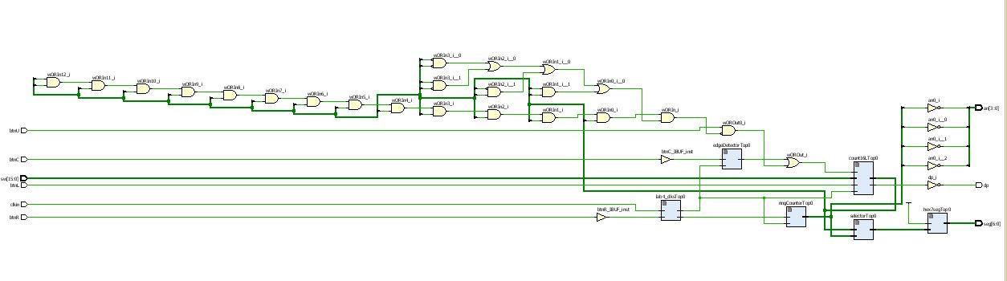

**Top Level Verilog:**

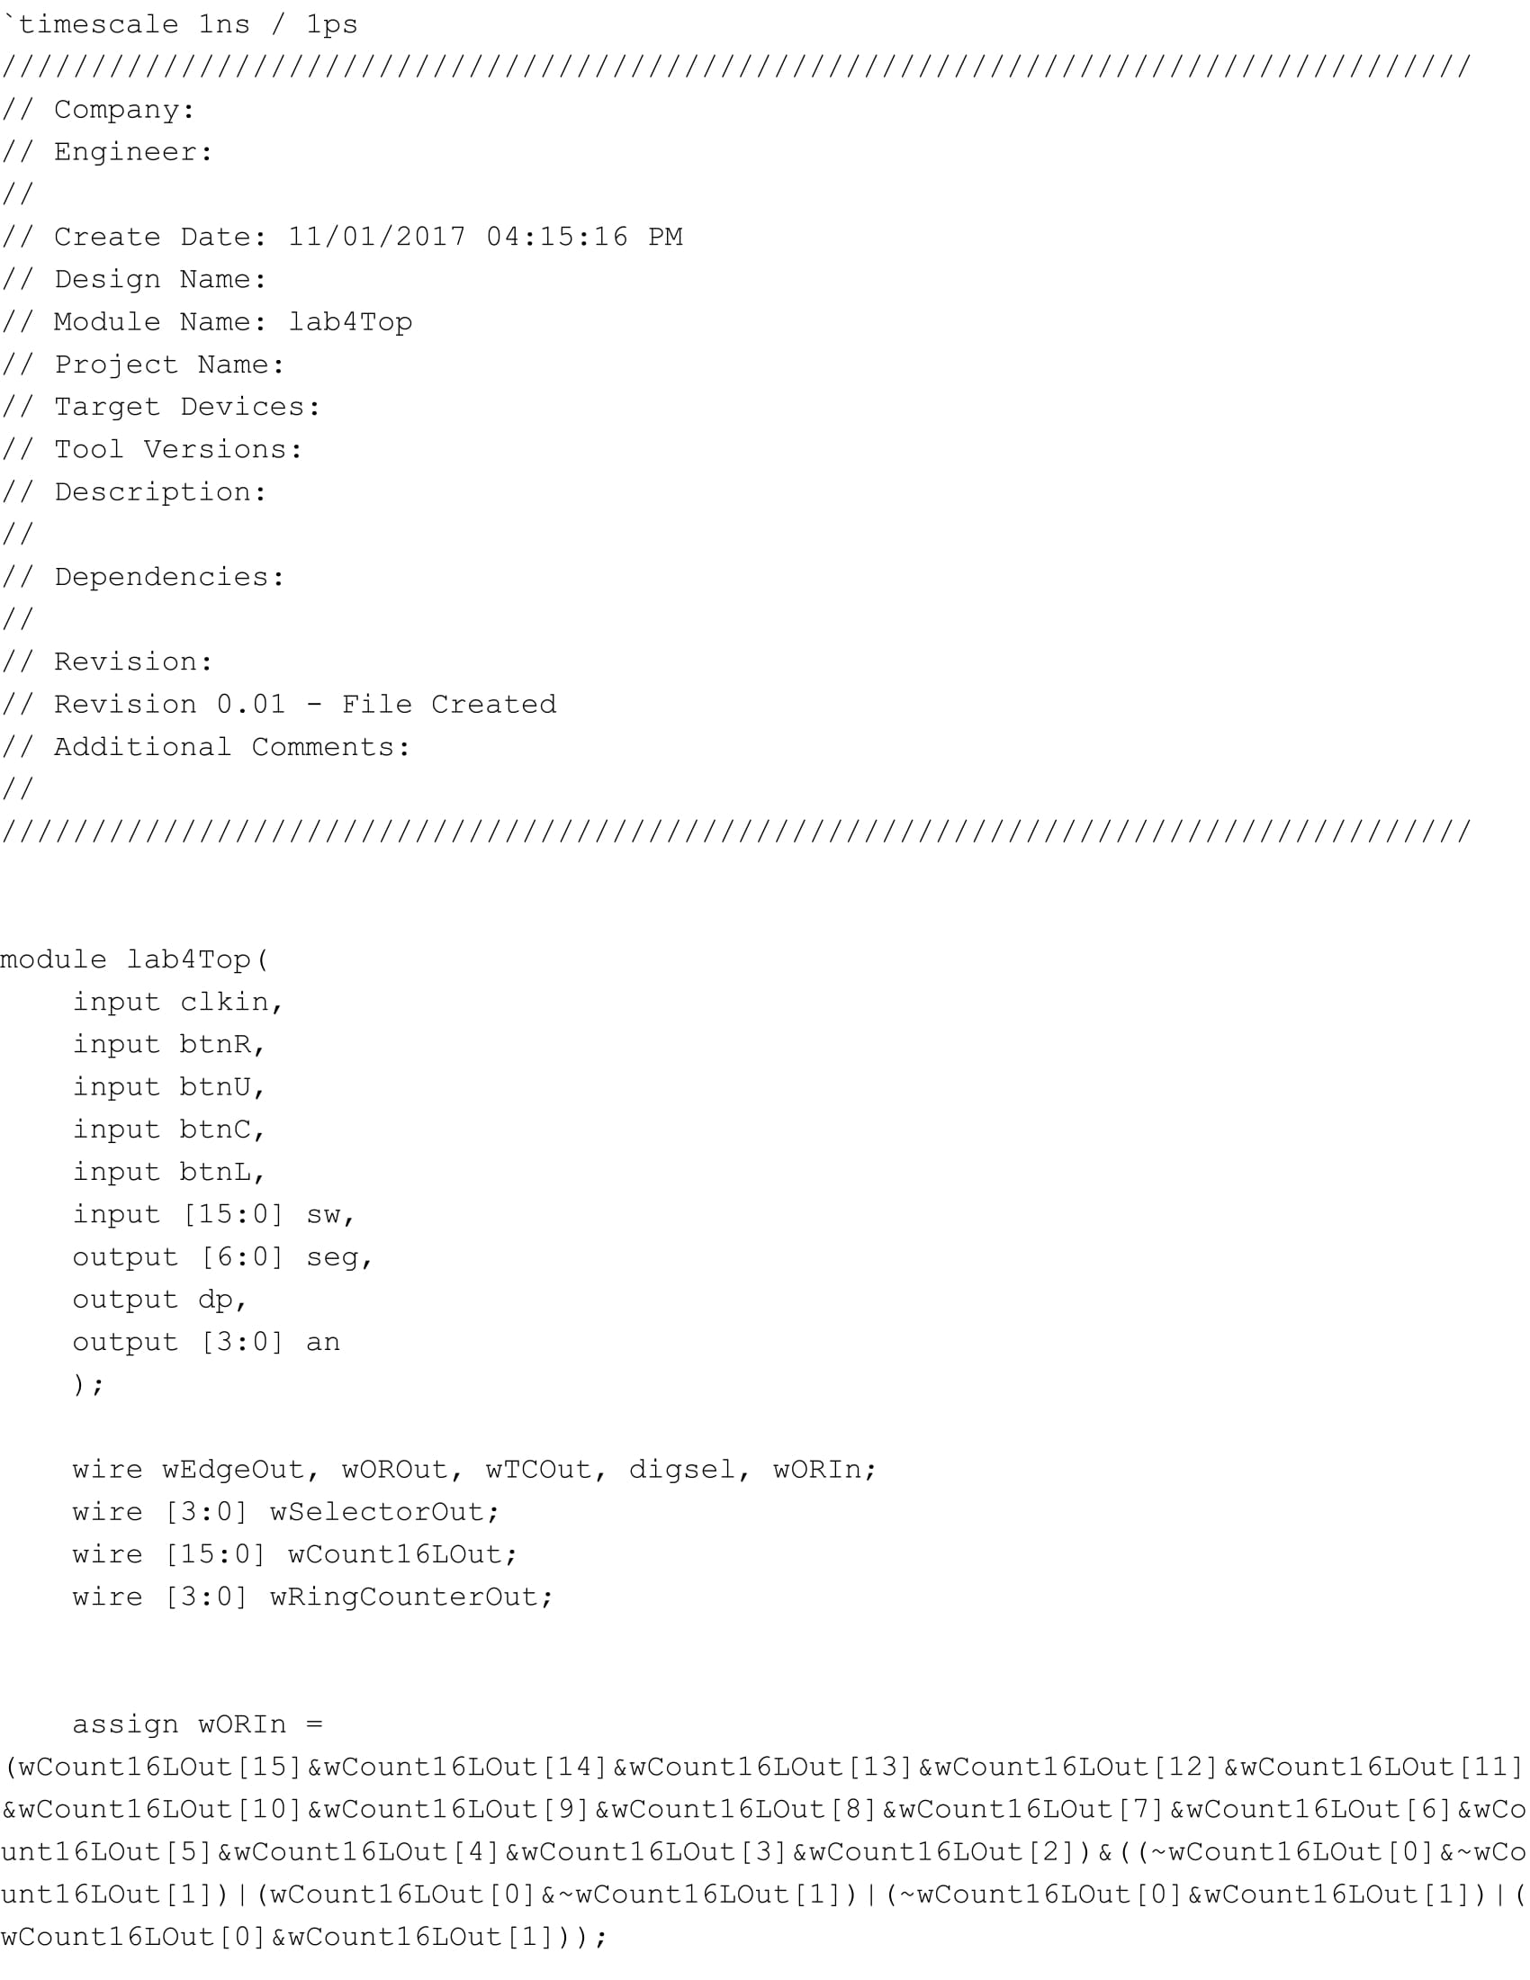

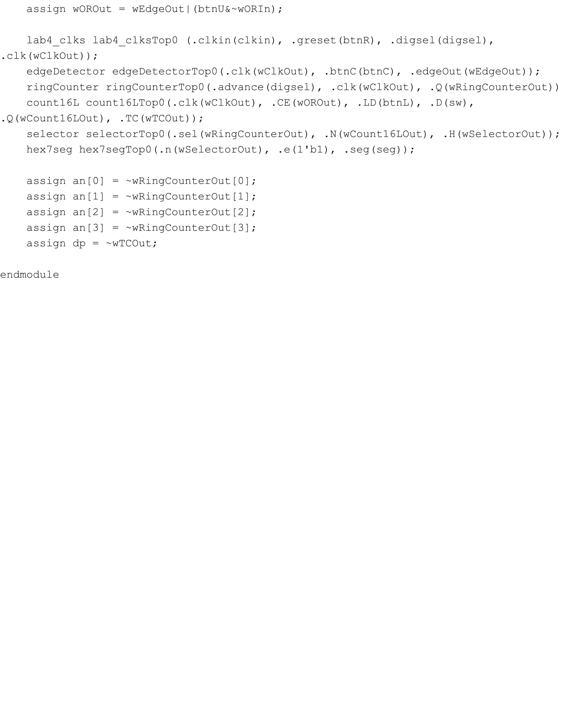

**Edge Detector Schematic:**

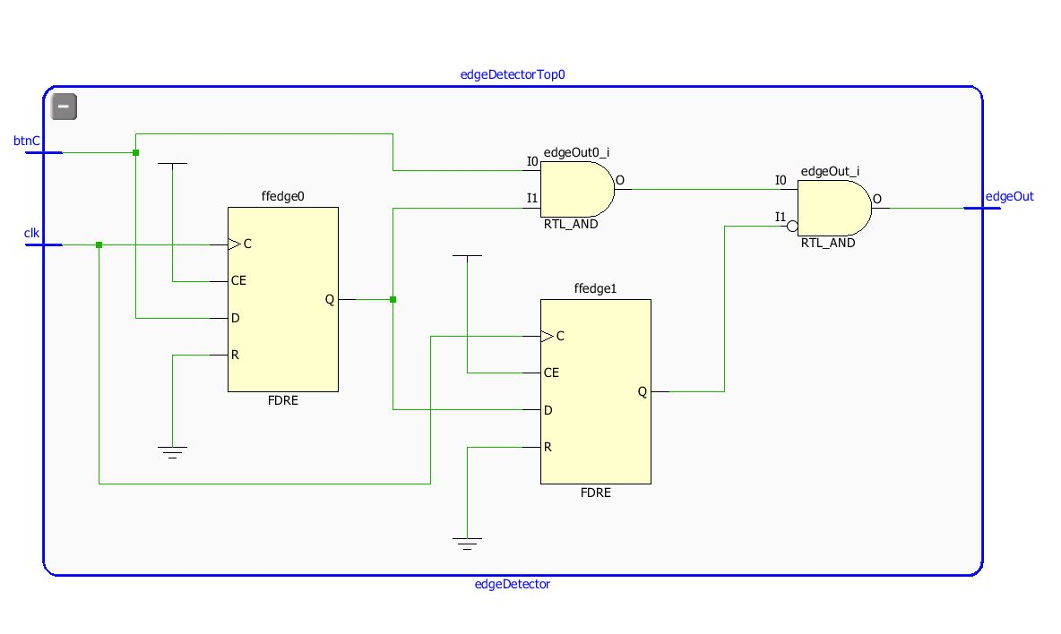

**Edge Detector Verilog:**

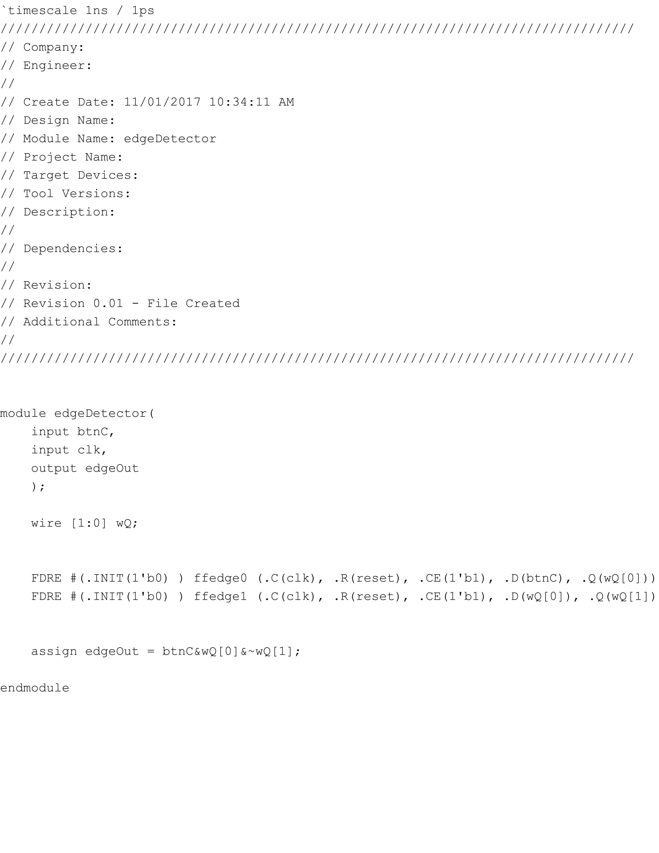

**Ring Counter Schematic:**

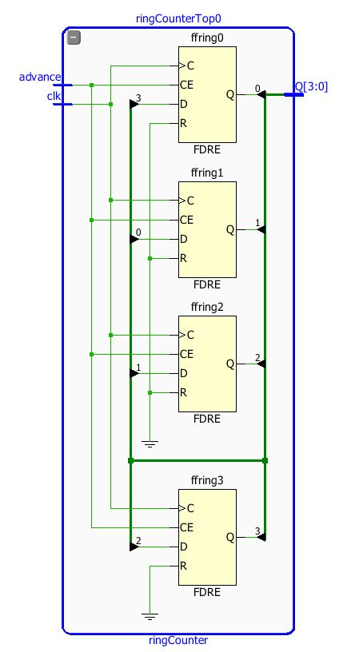

**Ring Counter Verilog:**

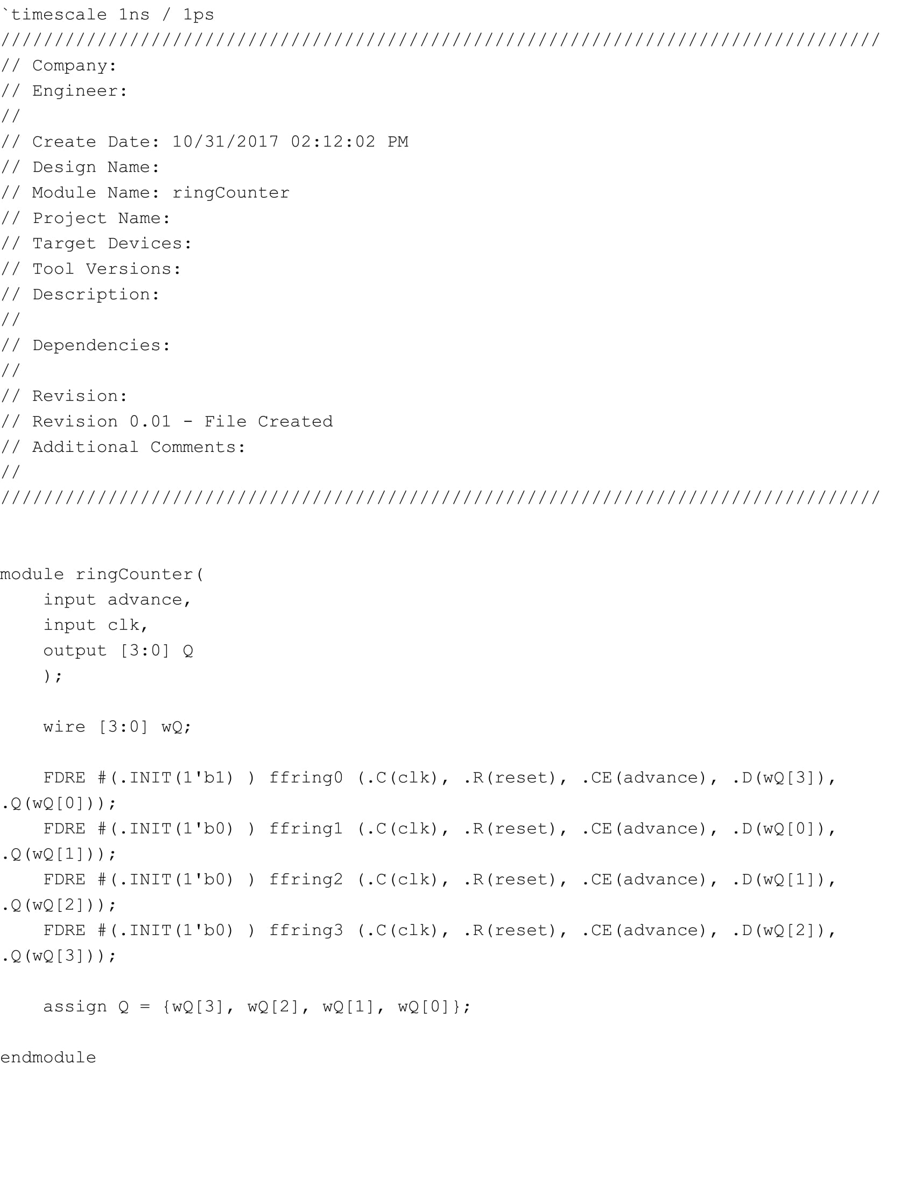

**Count16L Schematic:**

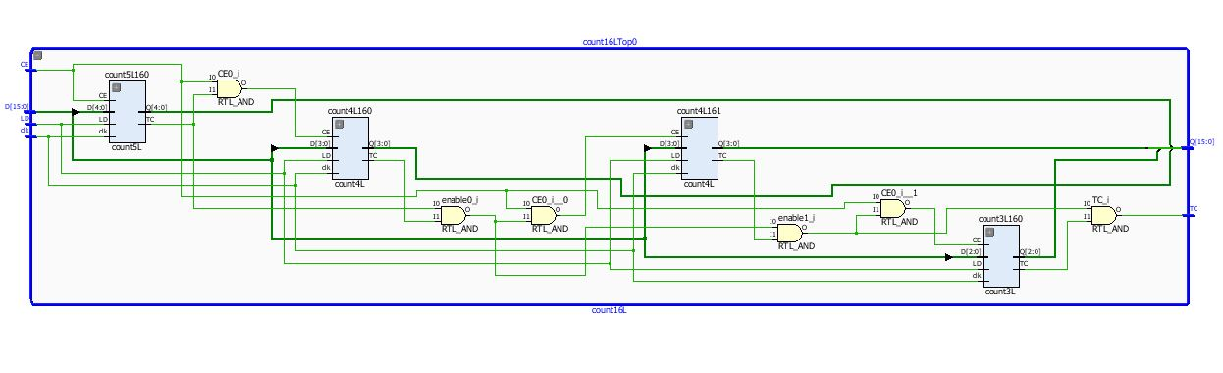

**Count16L Verilog:**

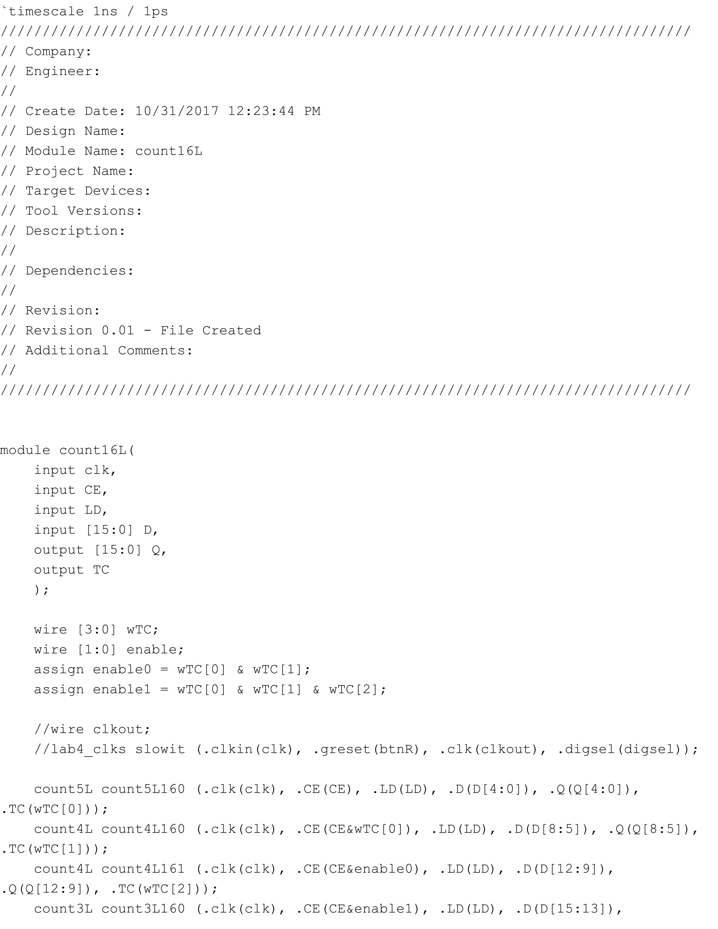

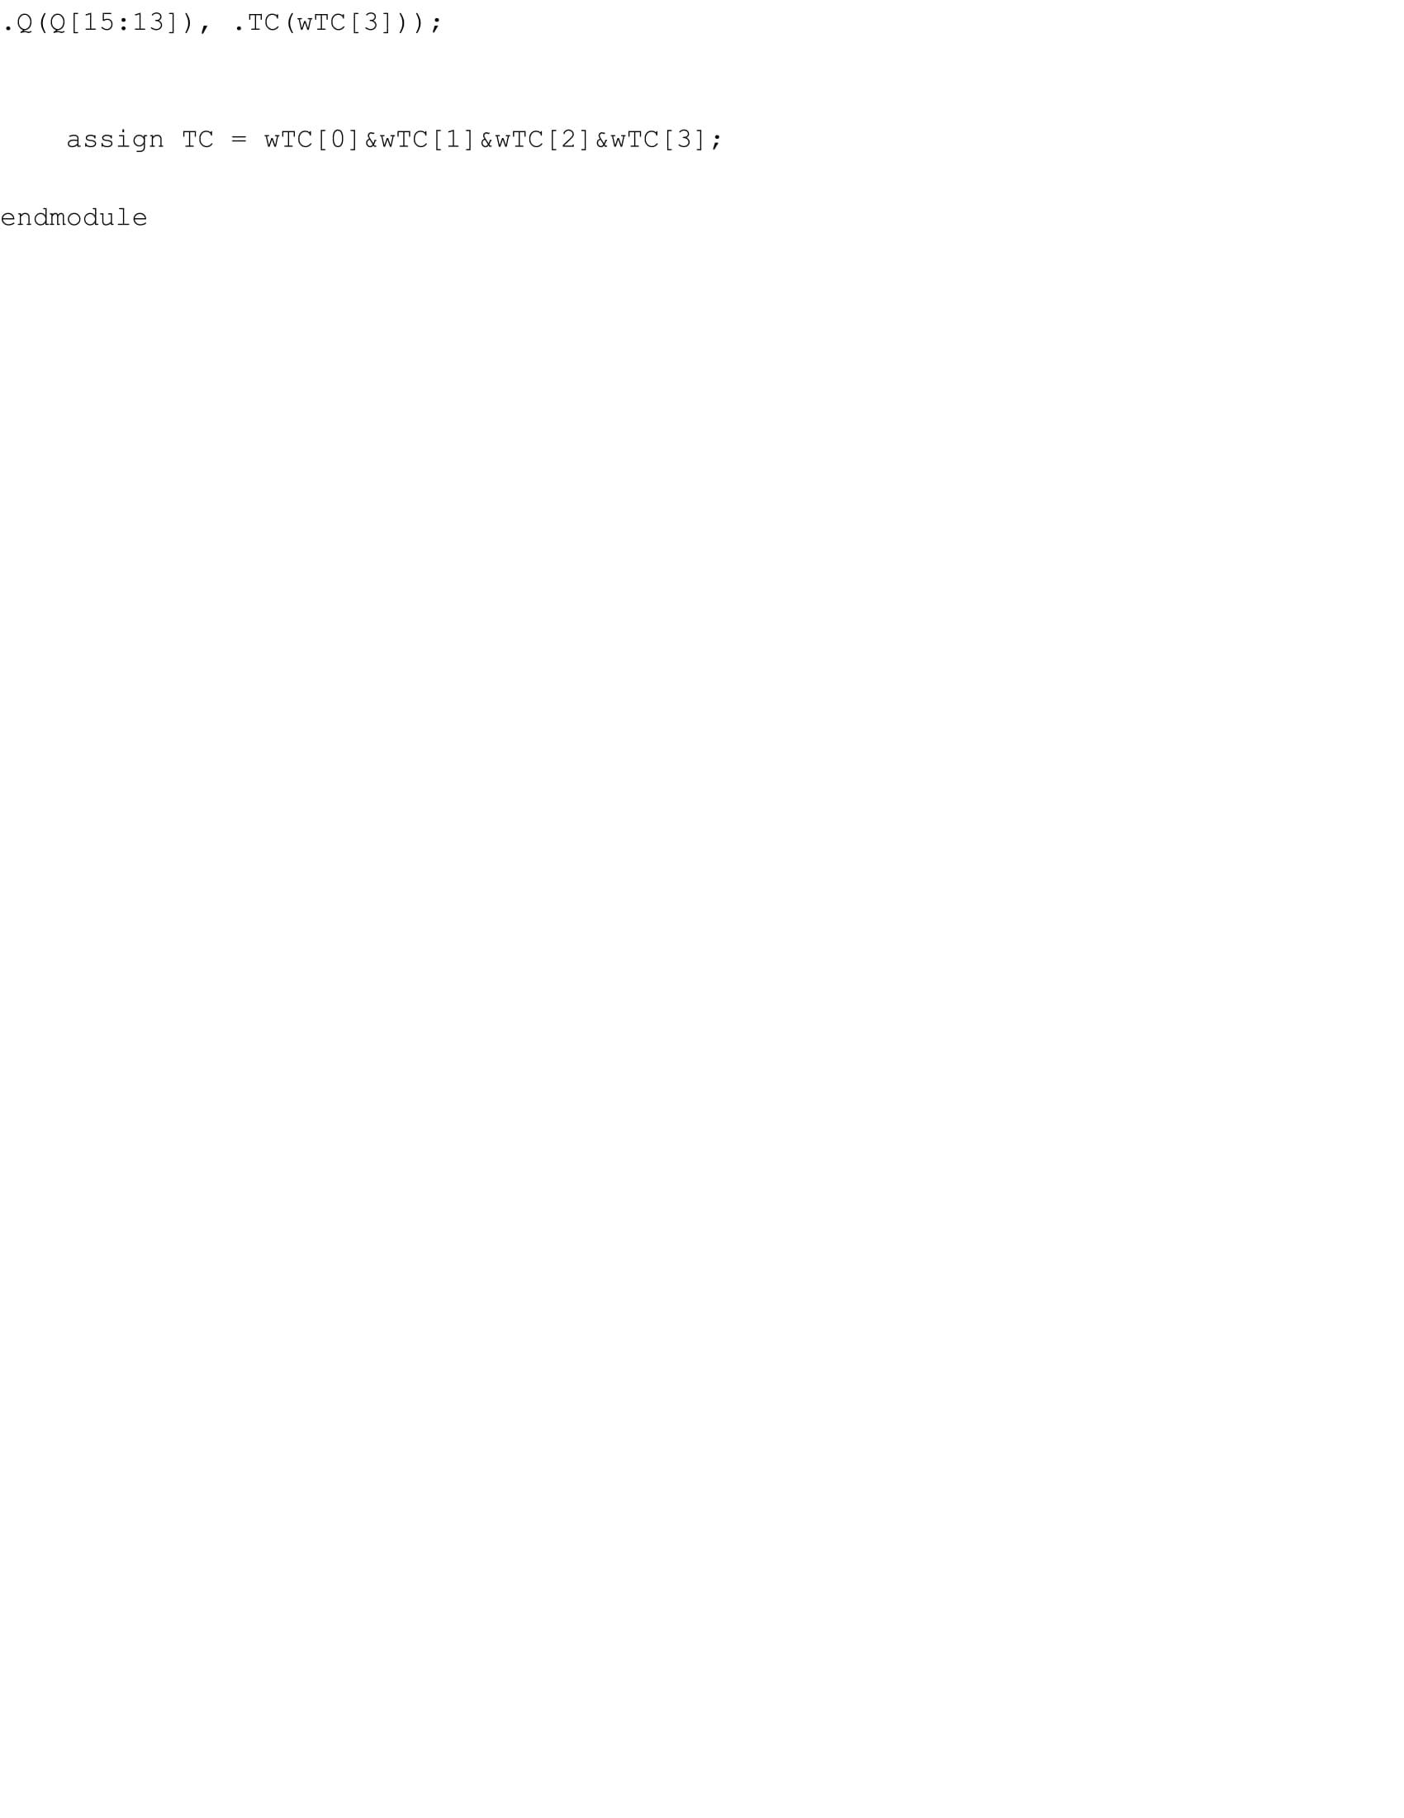

**Count5L Schematic:**

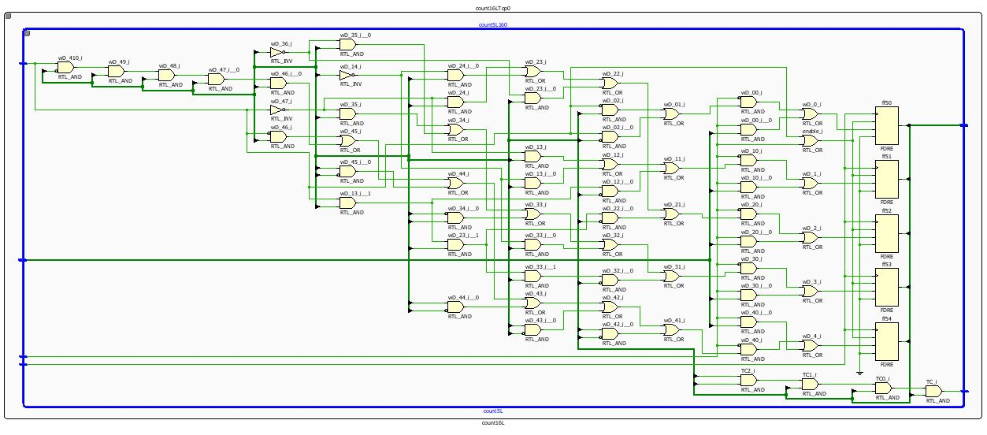

**Count5L Verilog:**

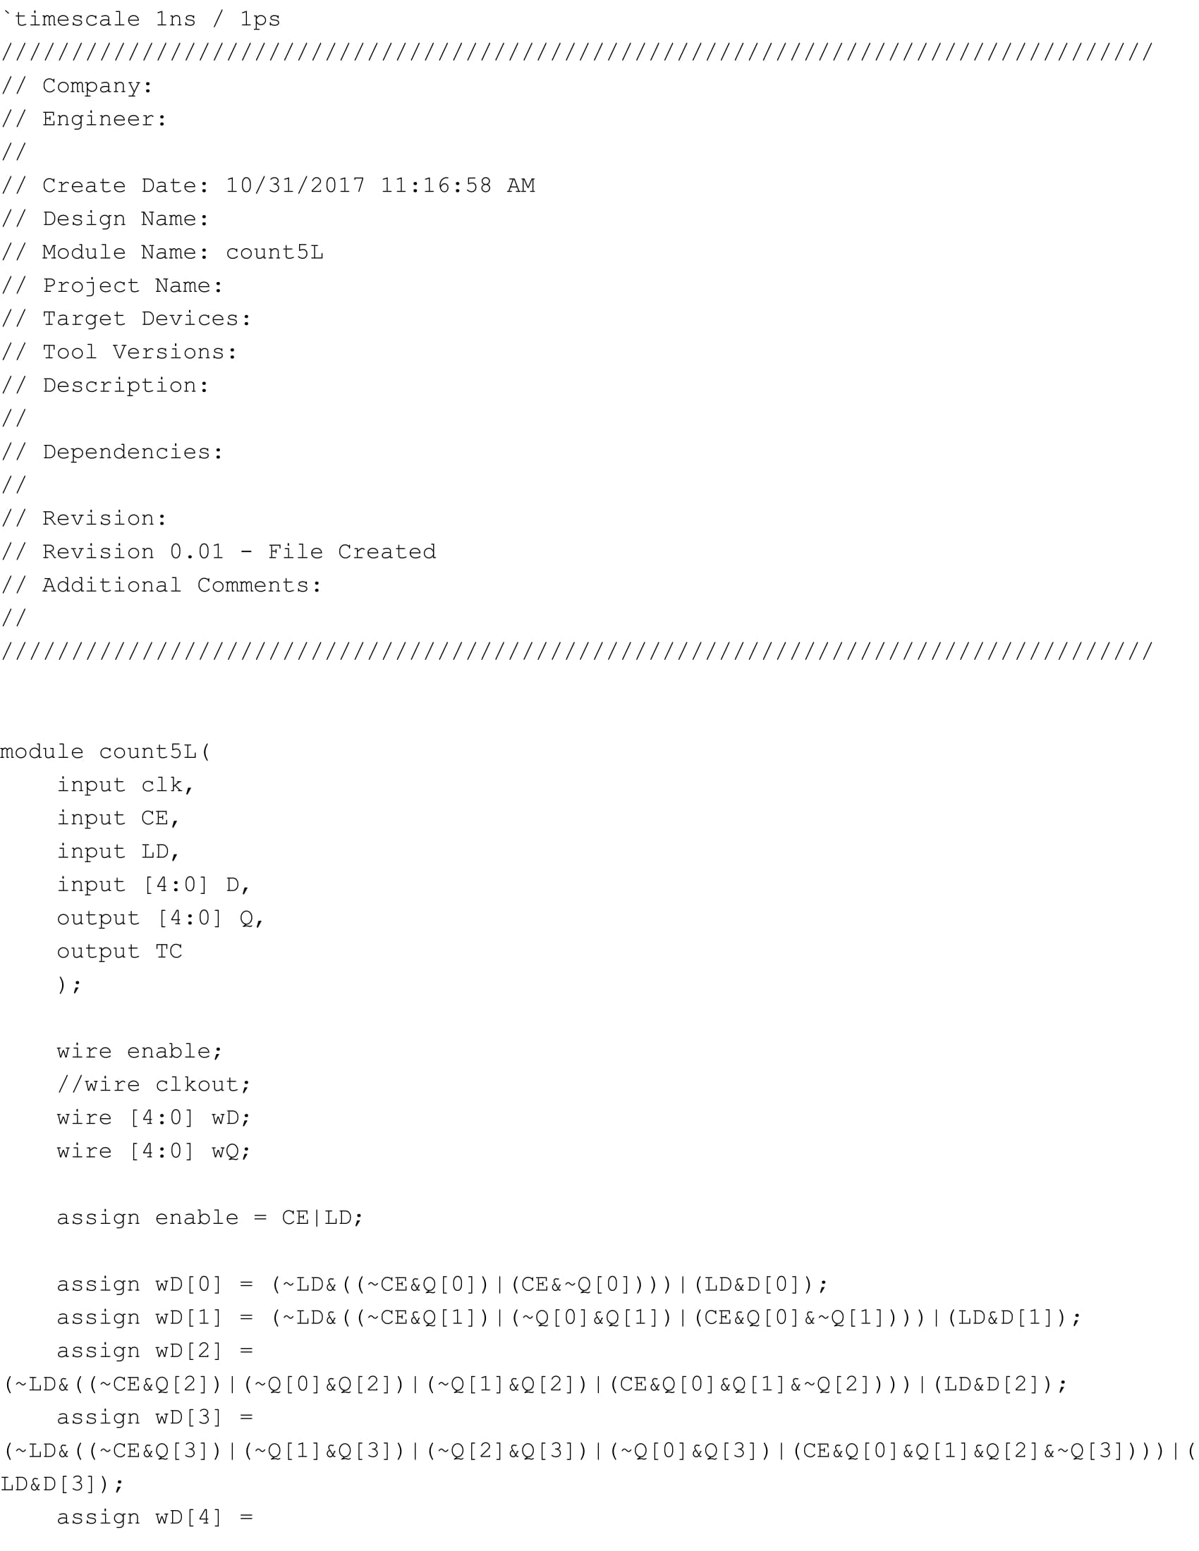

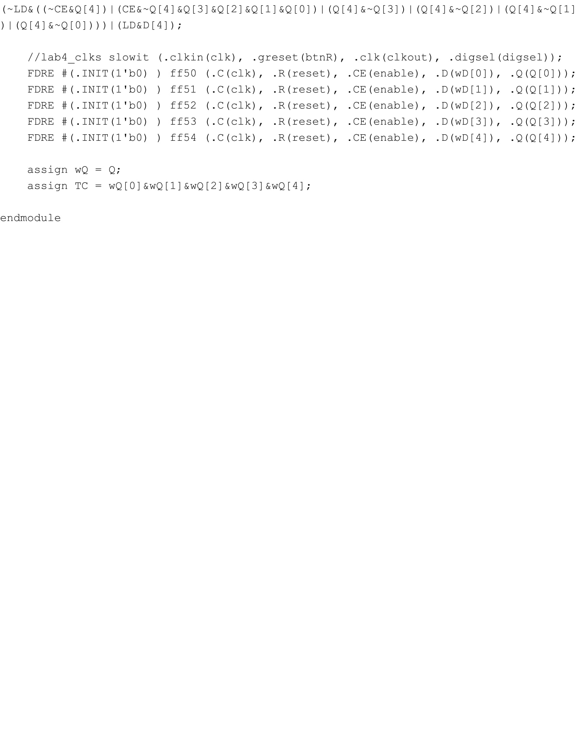

**Count4L Schematic:**

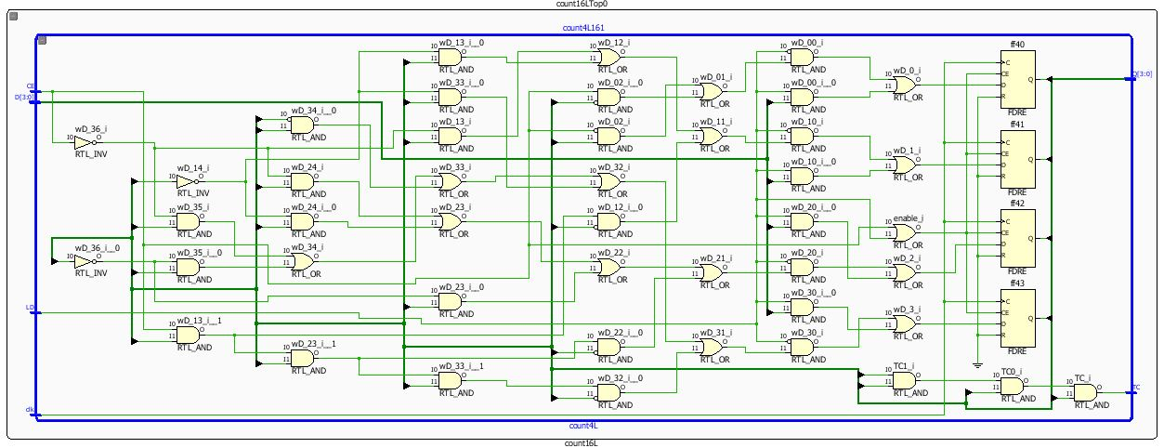

**Count 4L Verilog:**

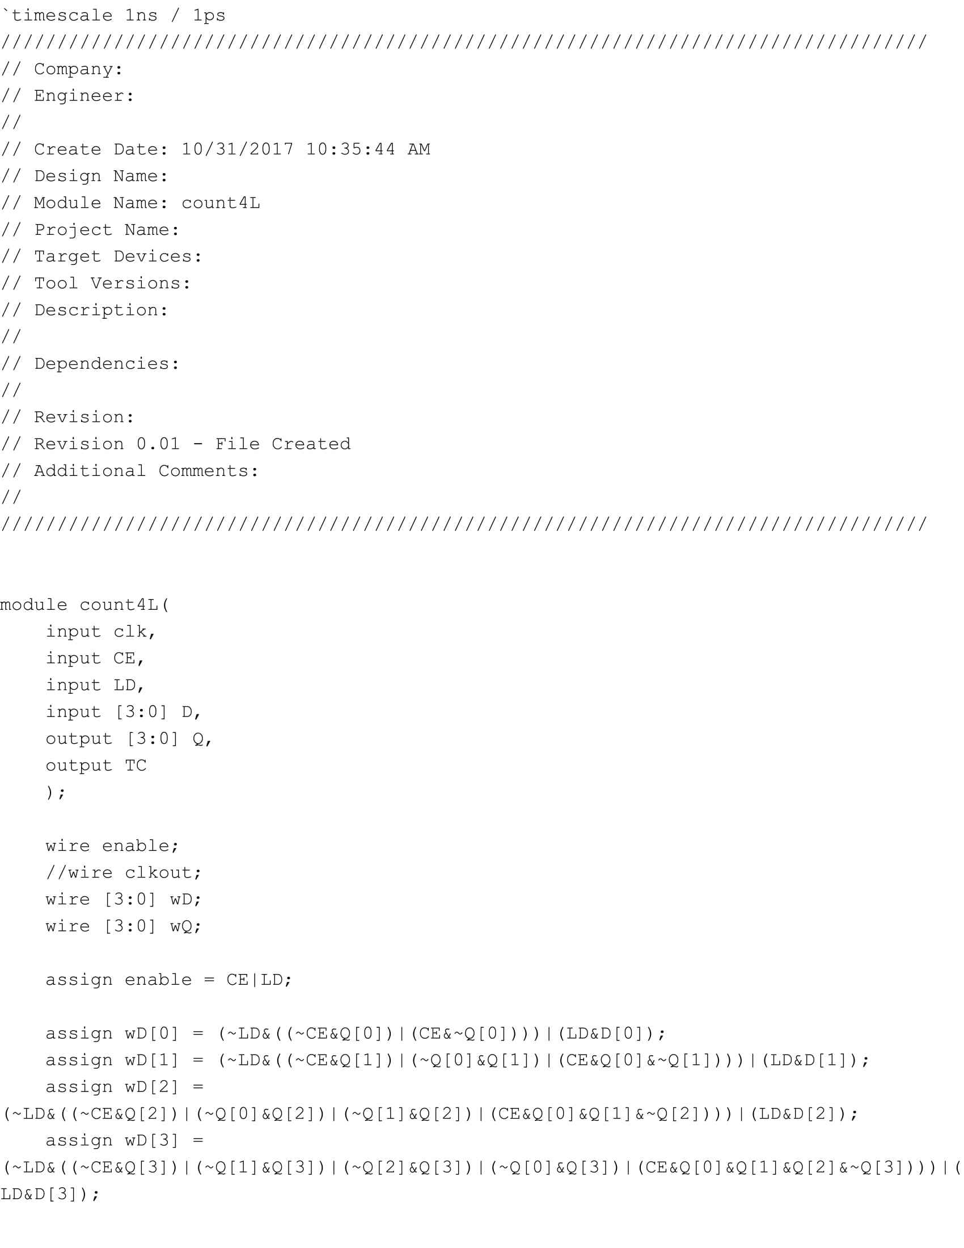

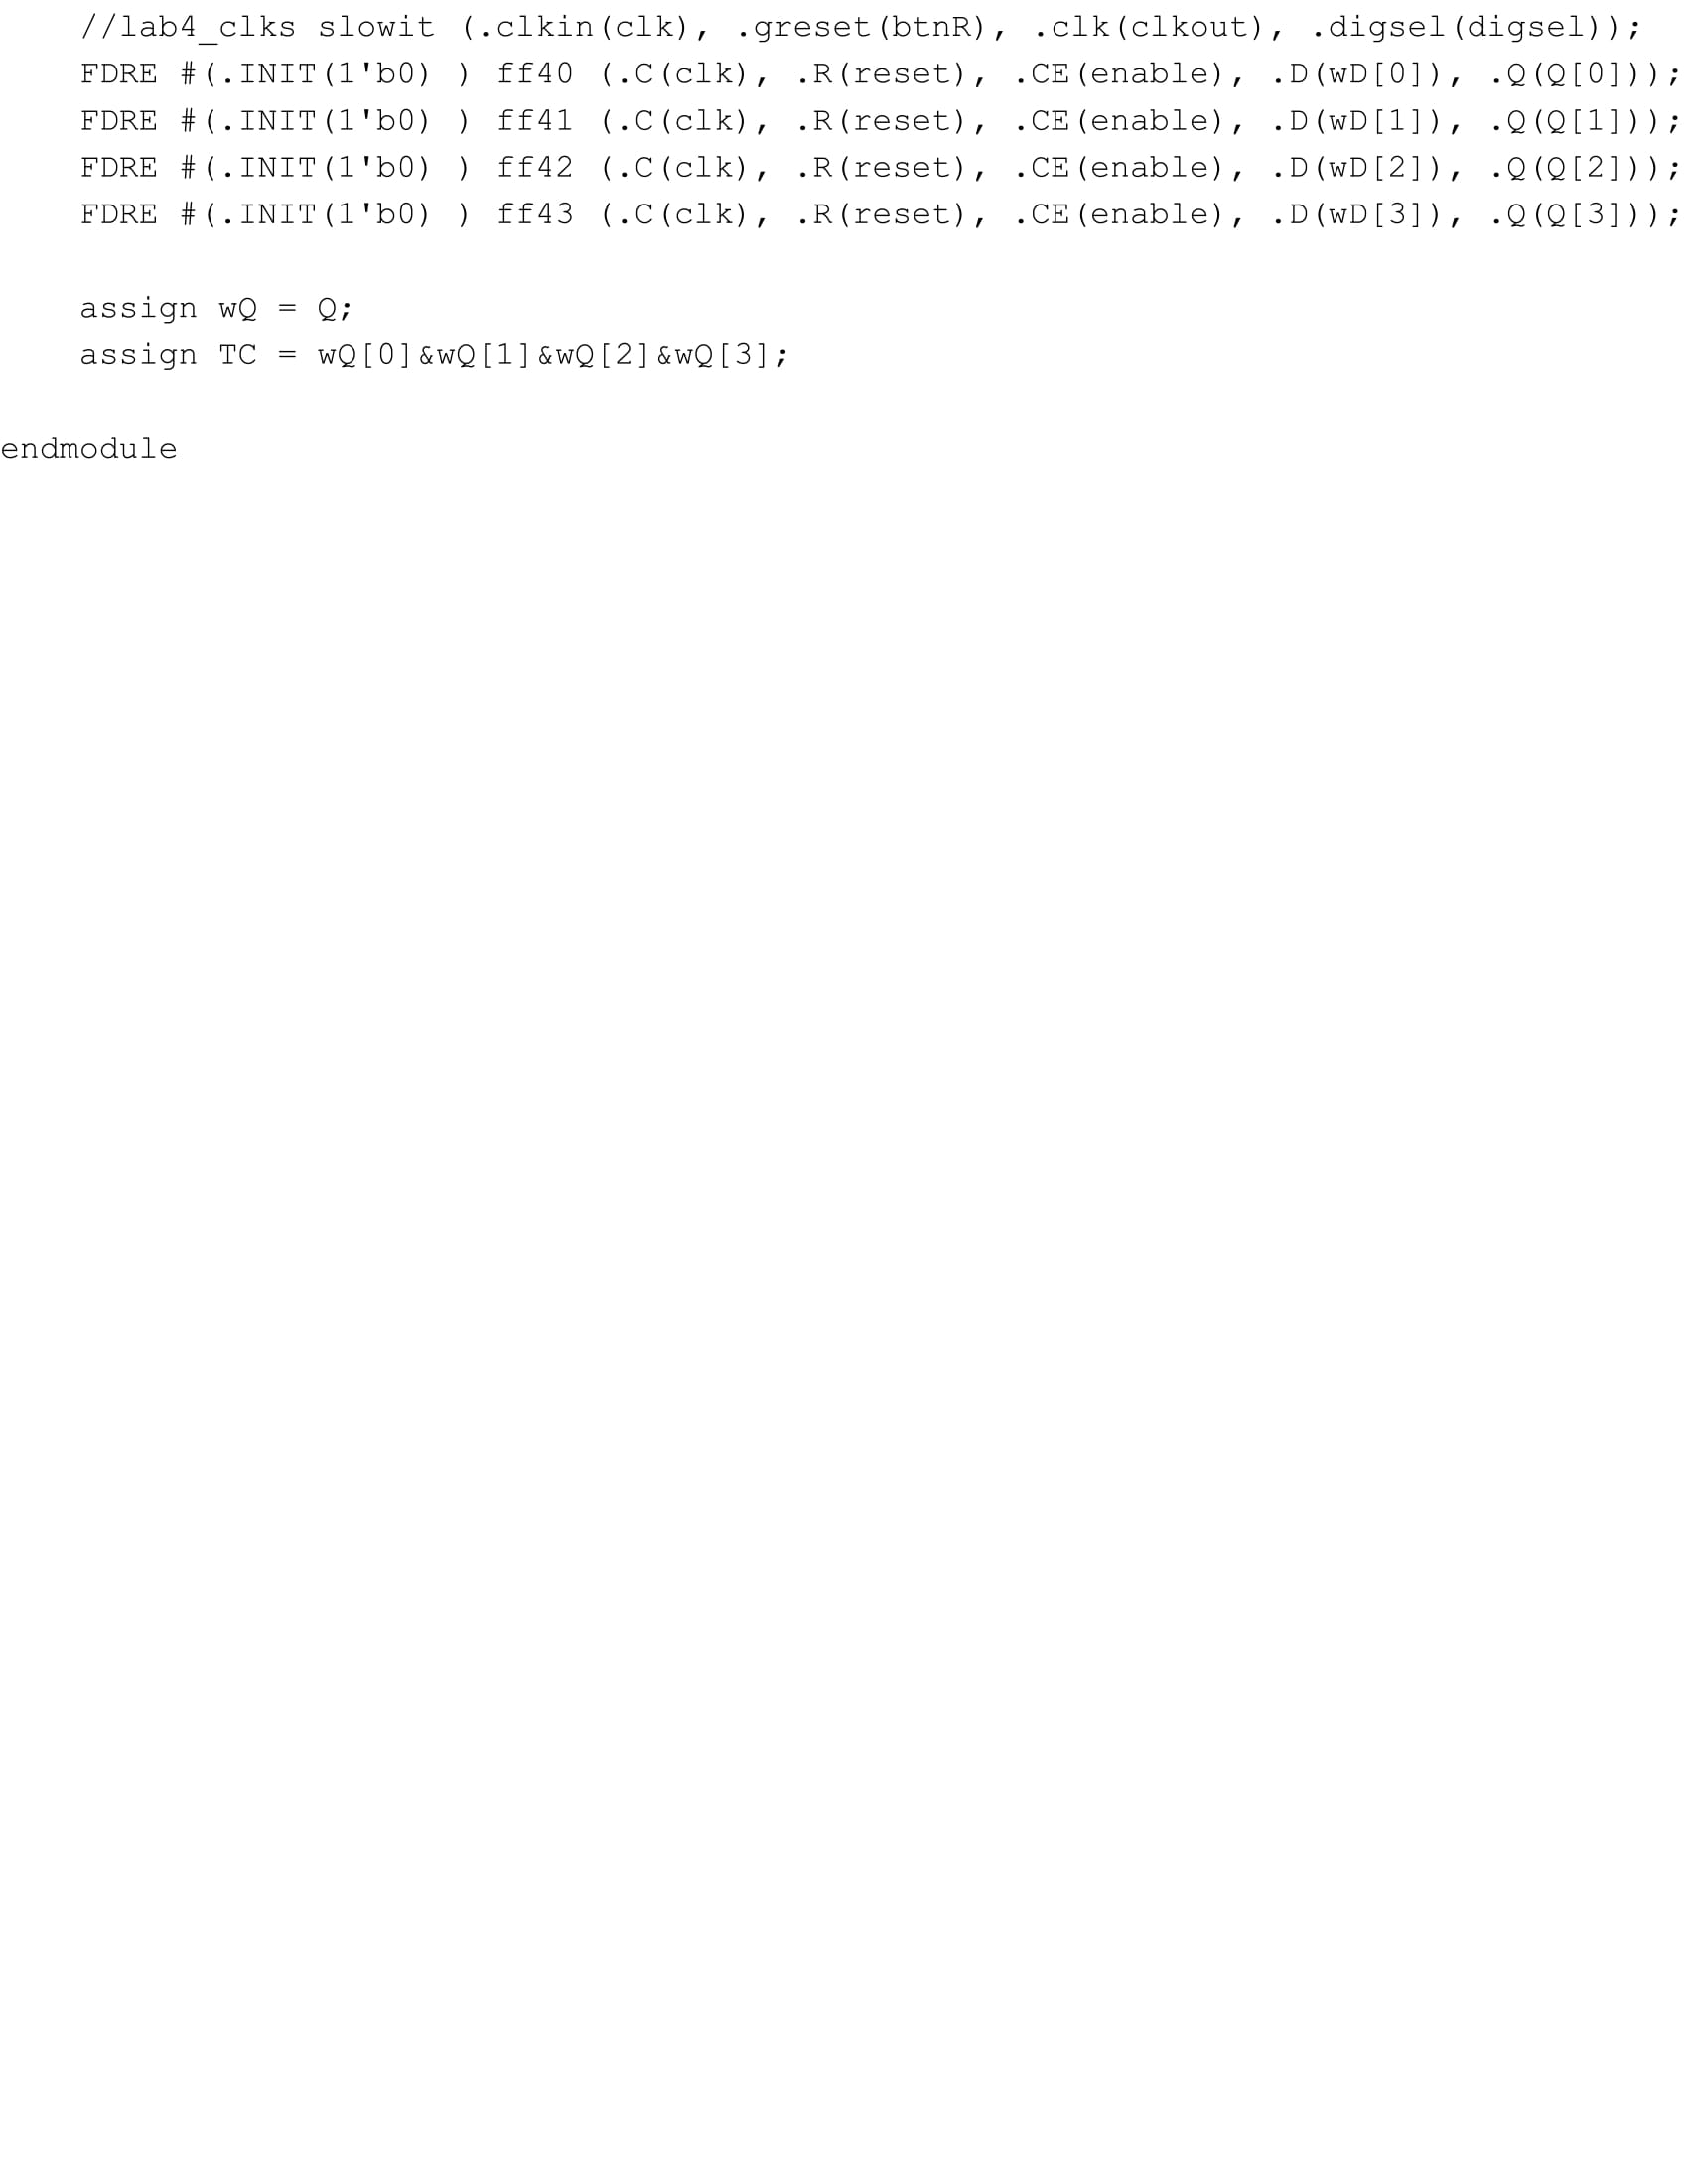

**Count3L Schematic:**

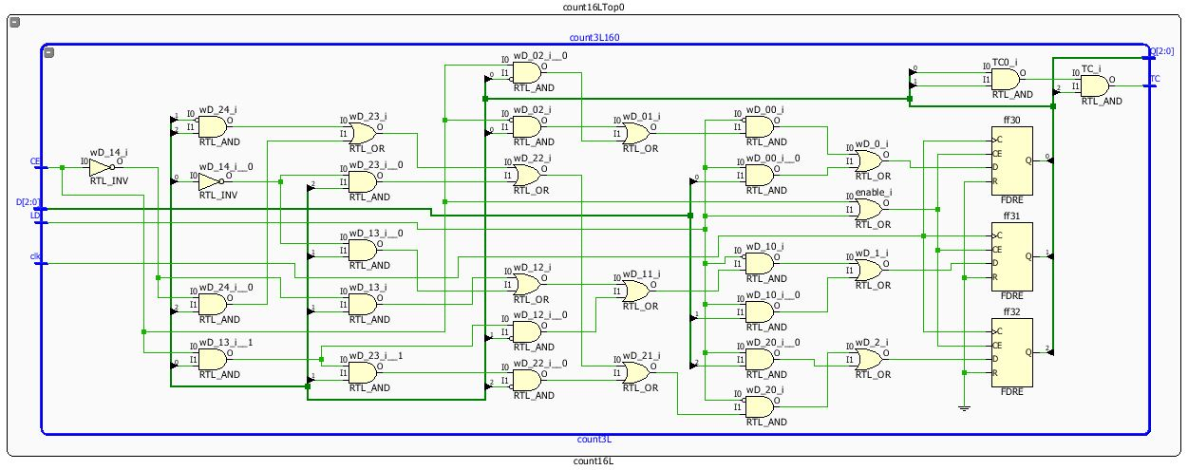

**Count3L Verilog:**

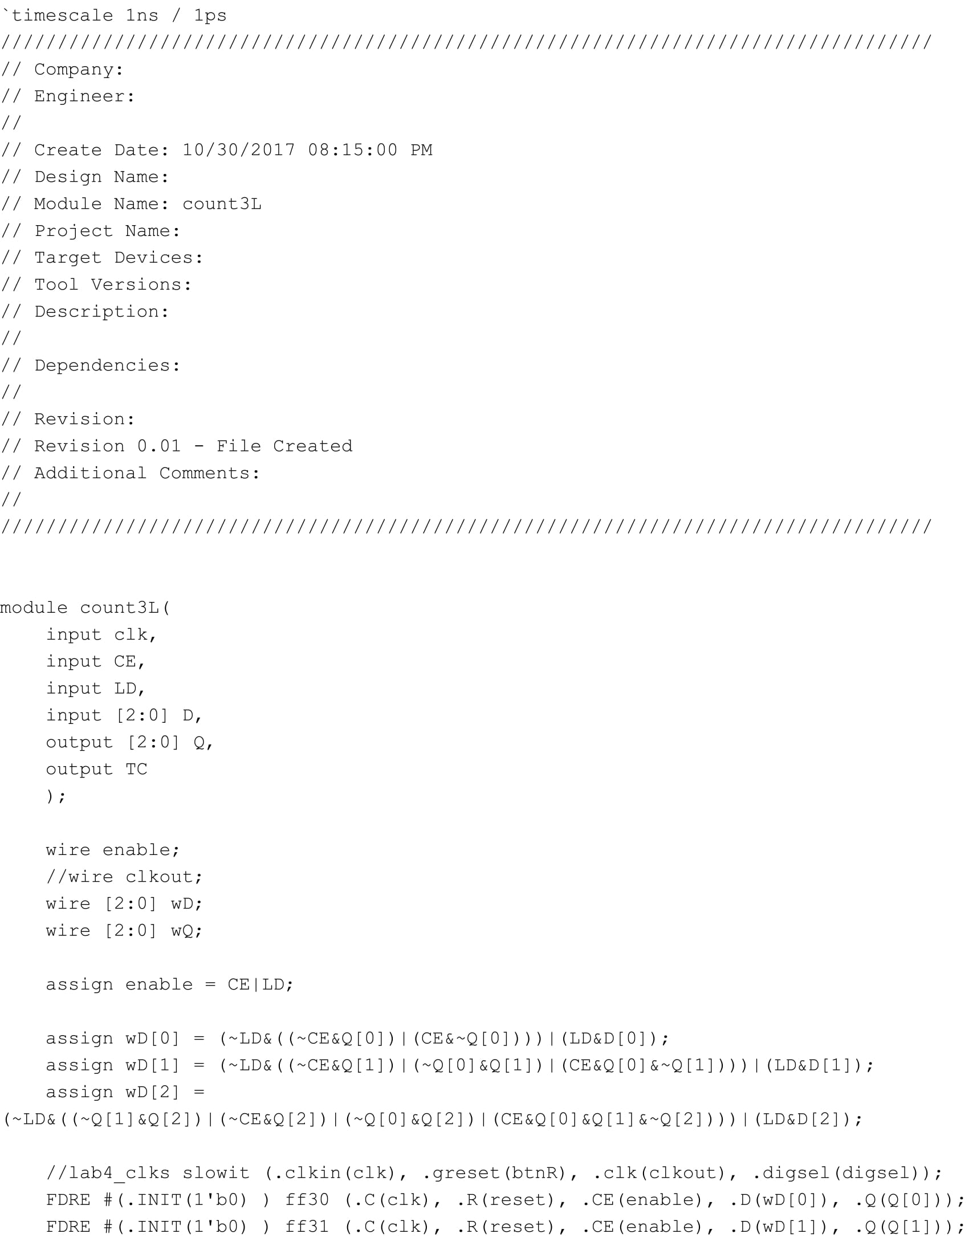

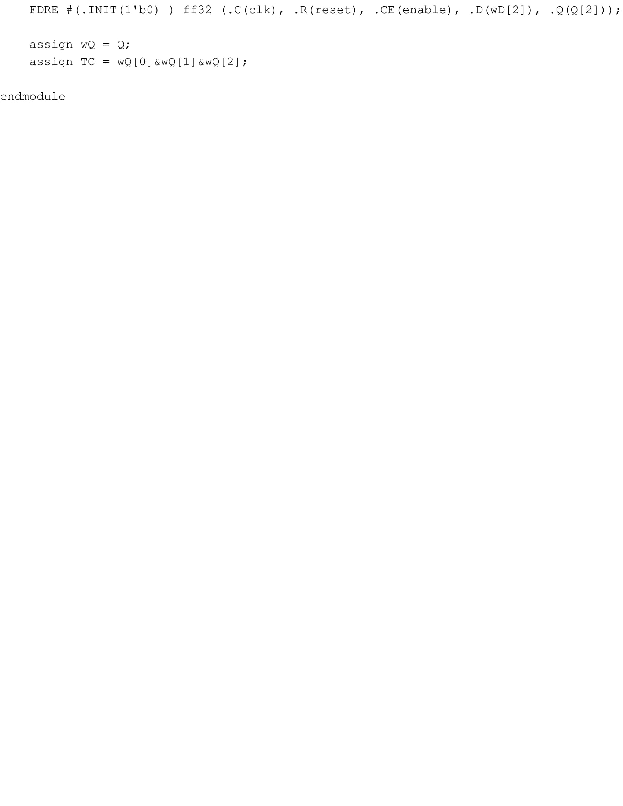

**Selector Schematic:**

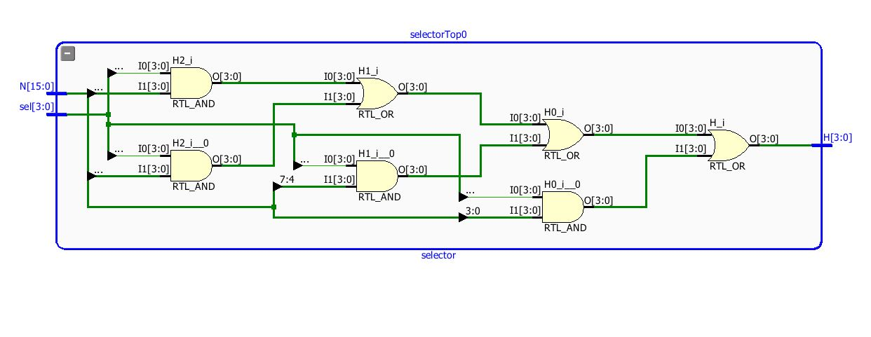

**Selector Verilog:**

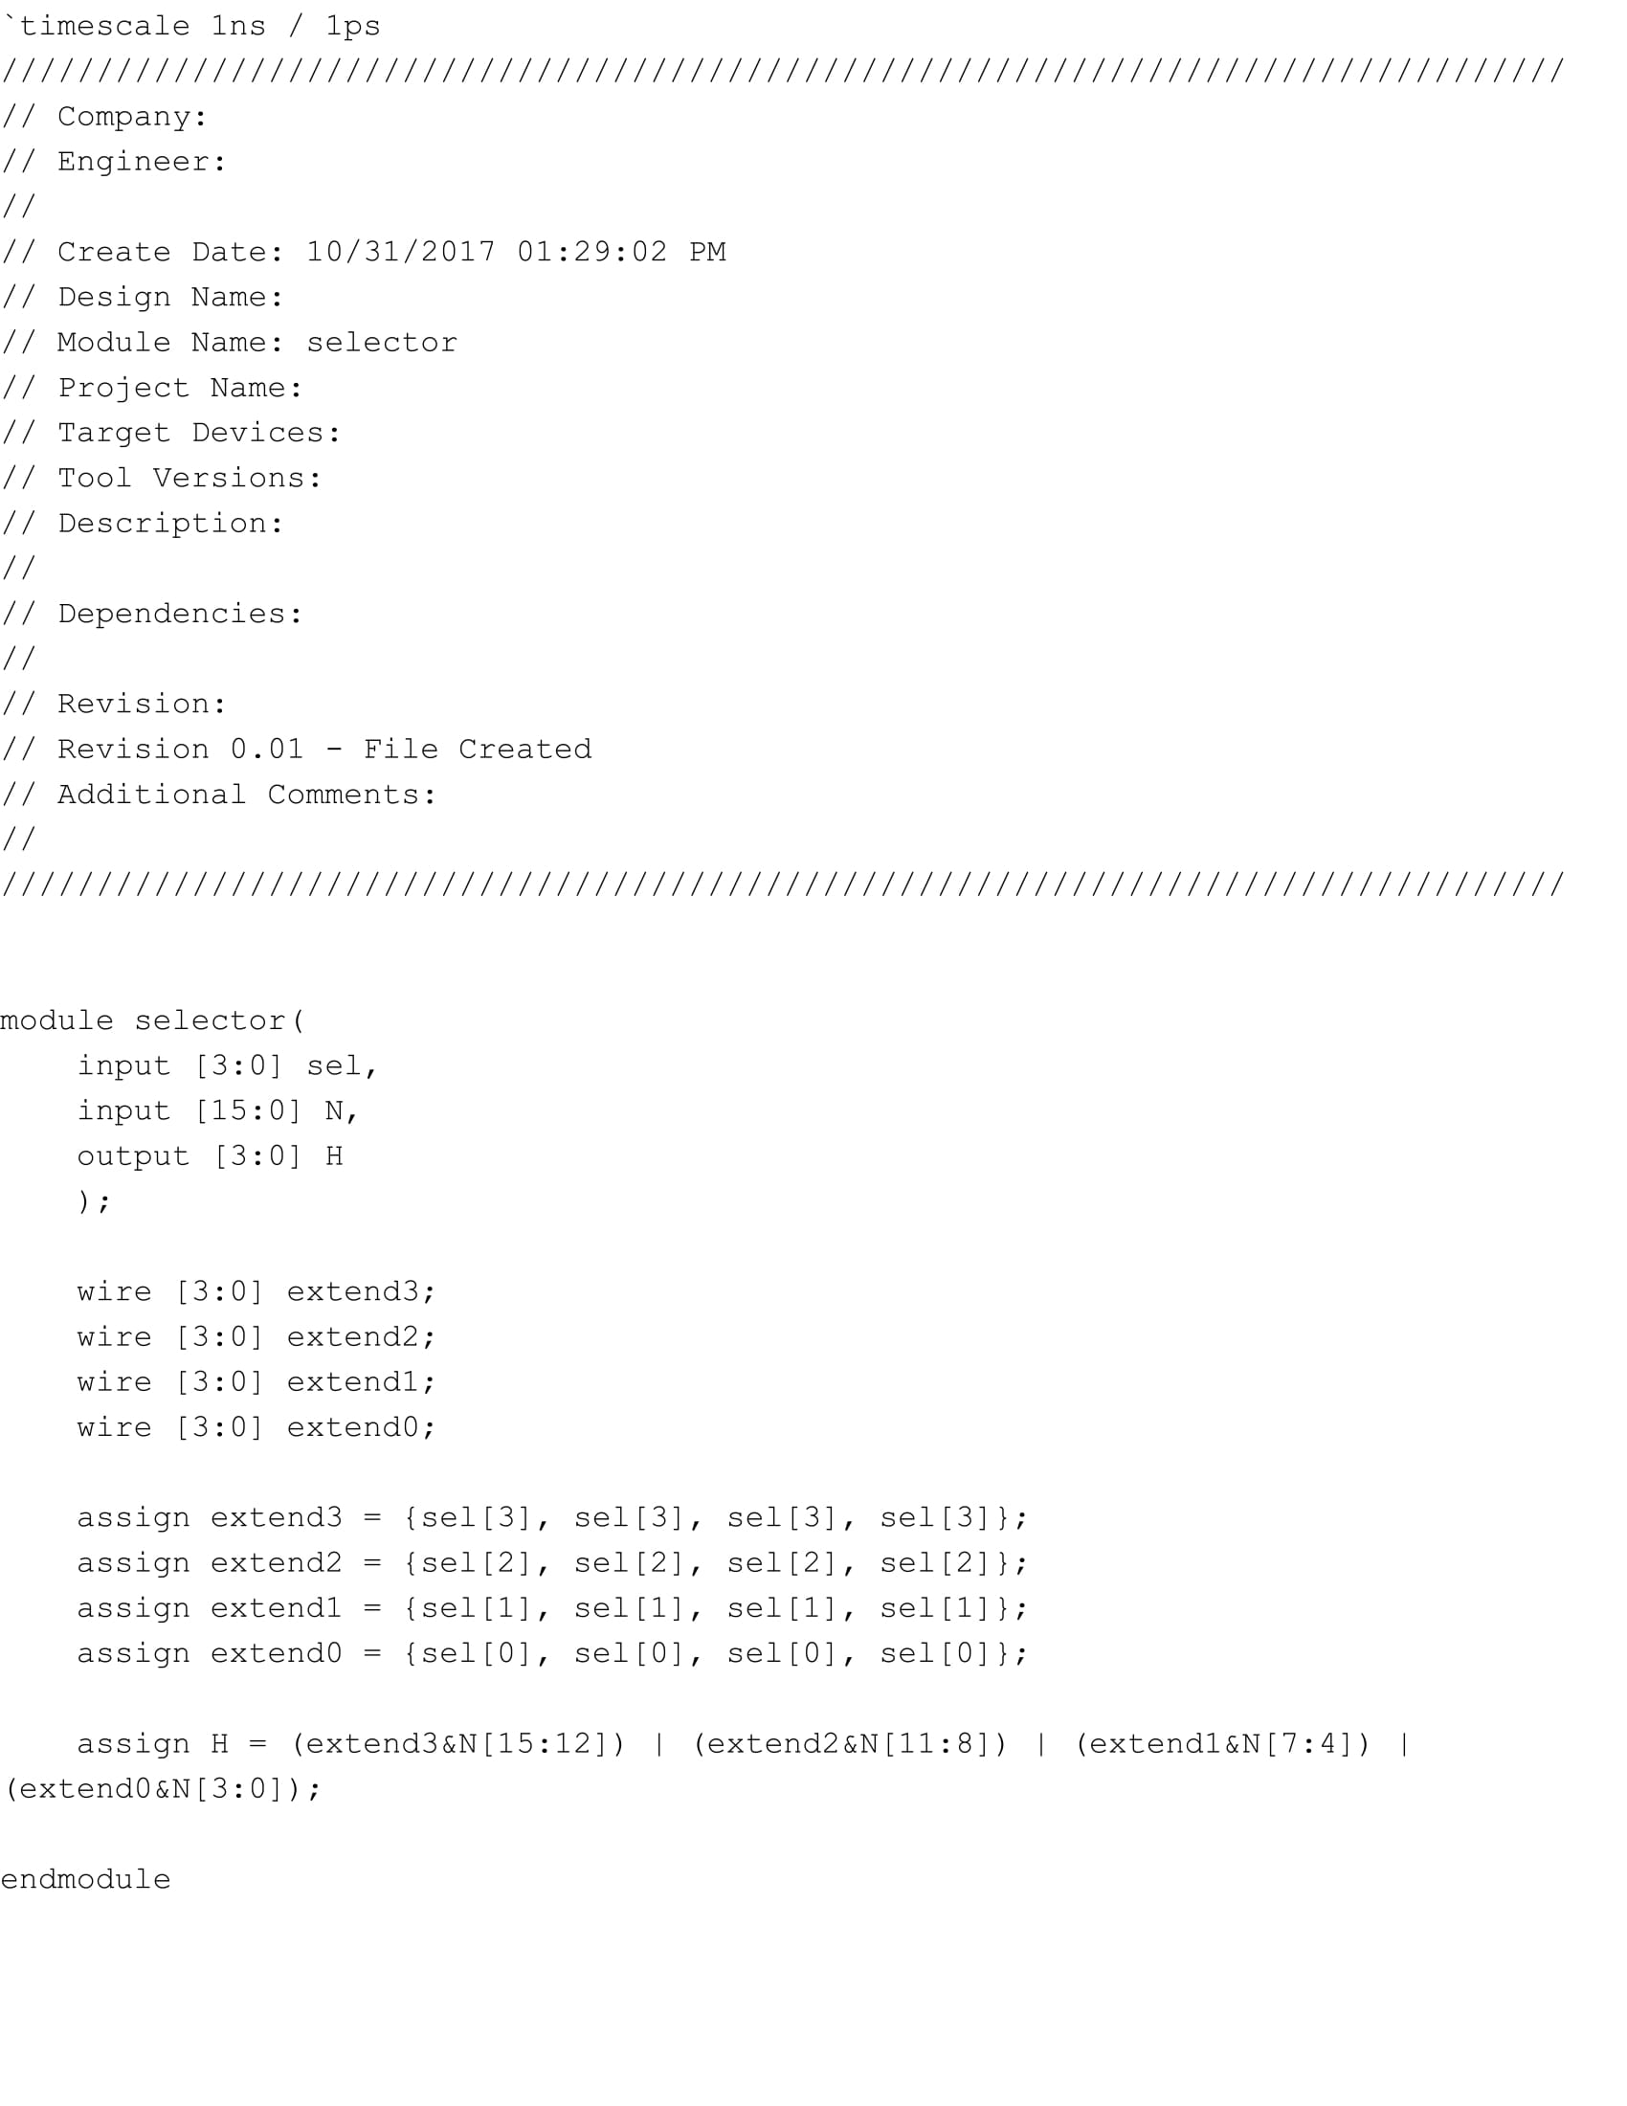

**Hex7Seg Schematic:**

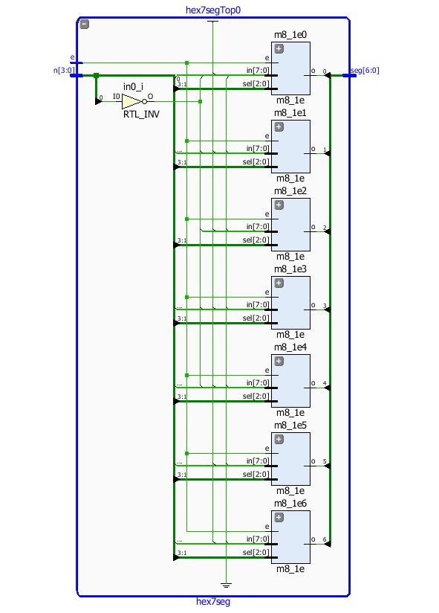

**Hex7Seg Verilog:**

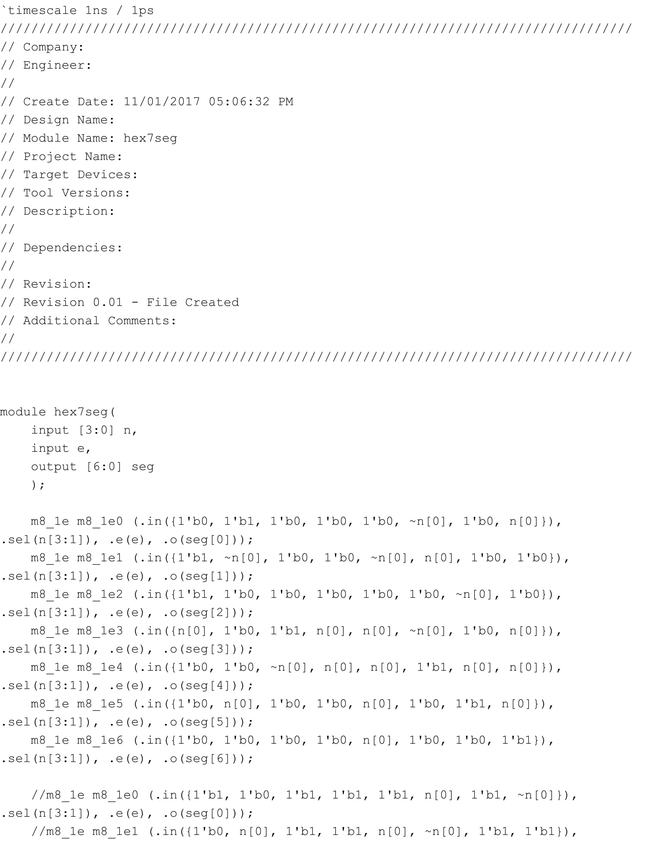

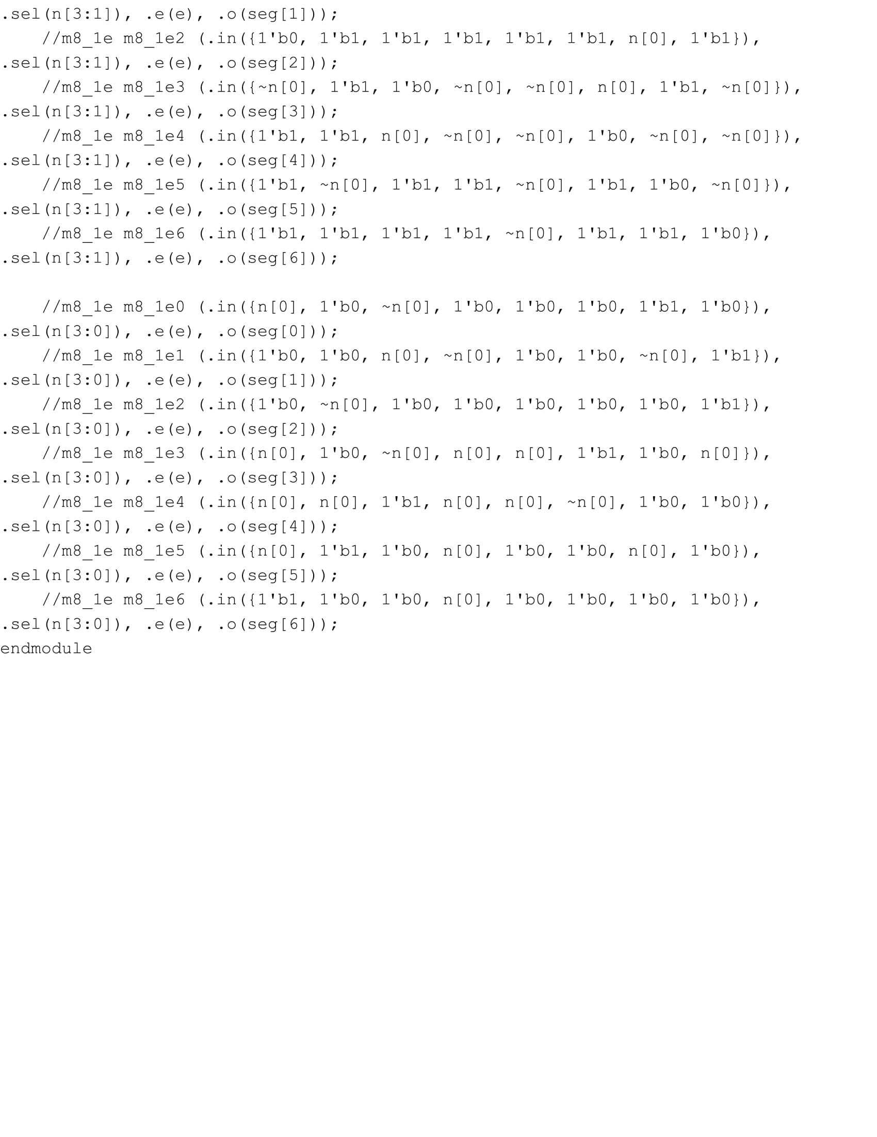

**M8_1e Schematic:**

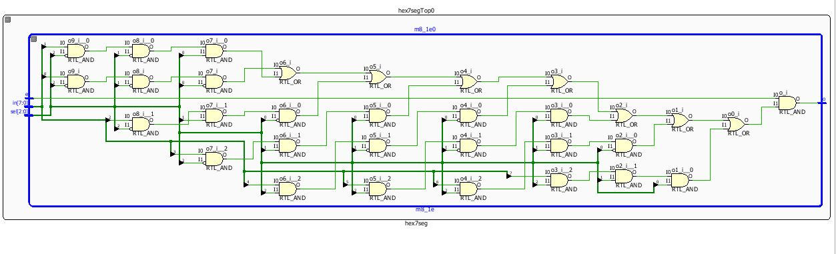

**M8_1e Verilog:**

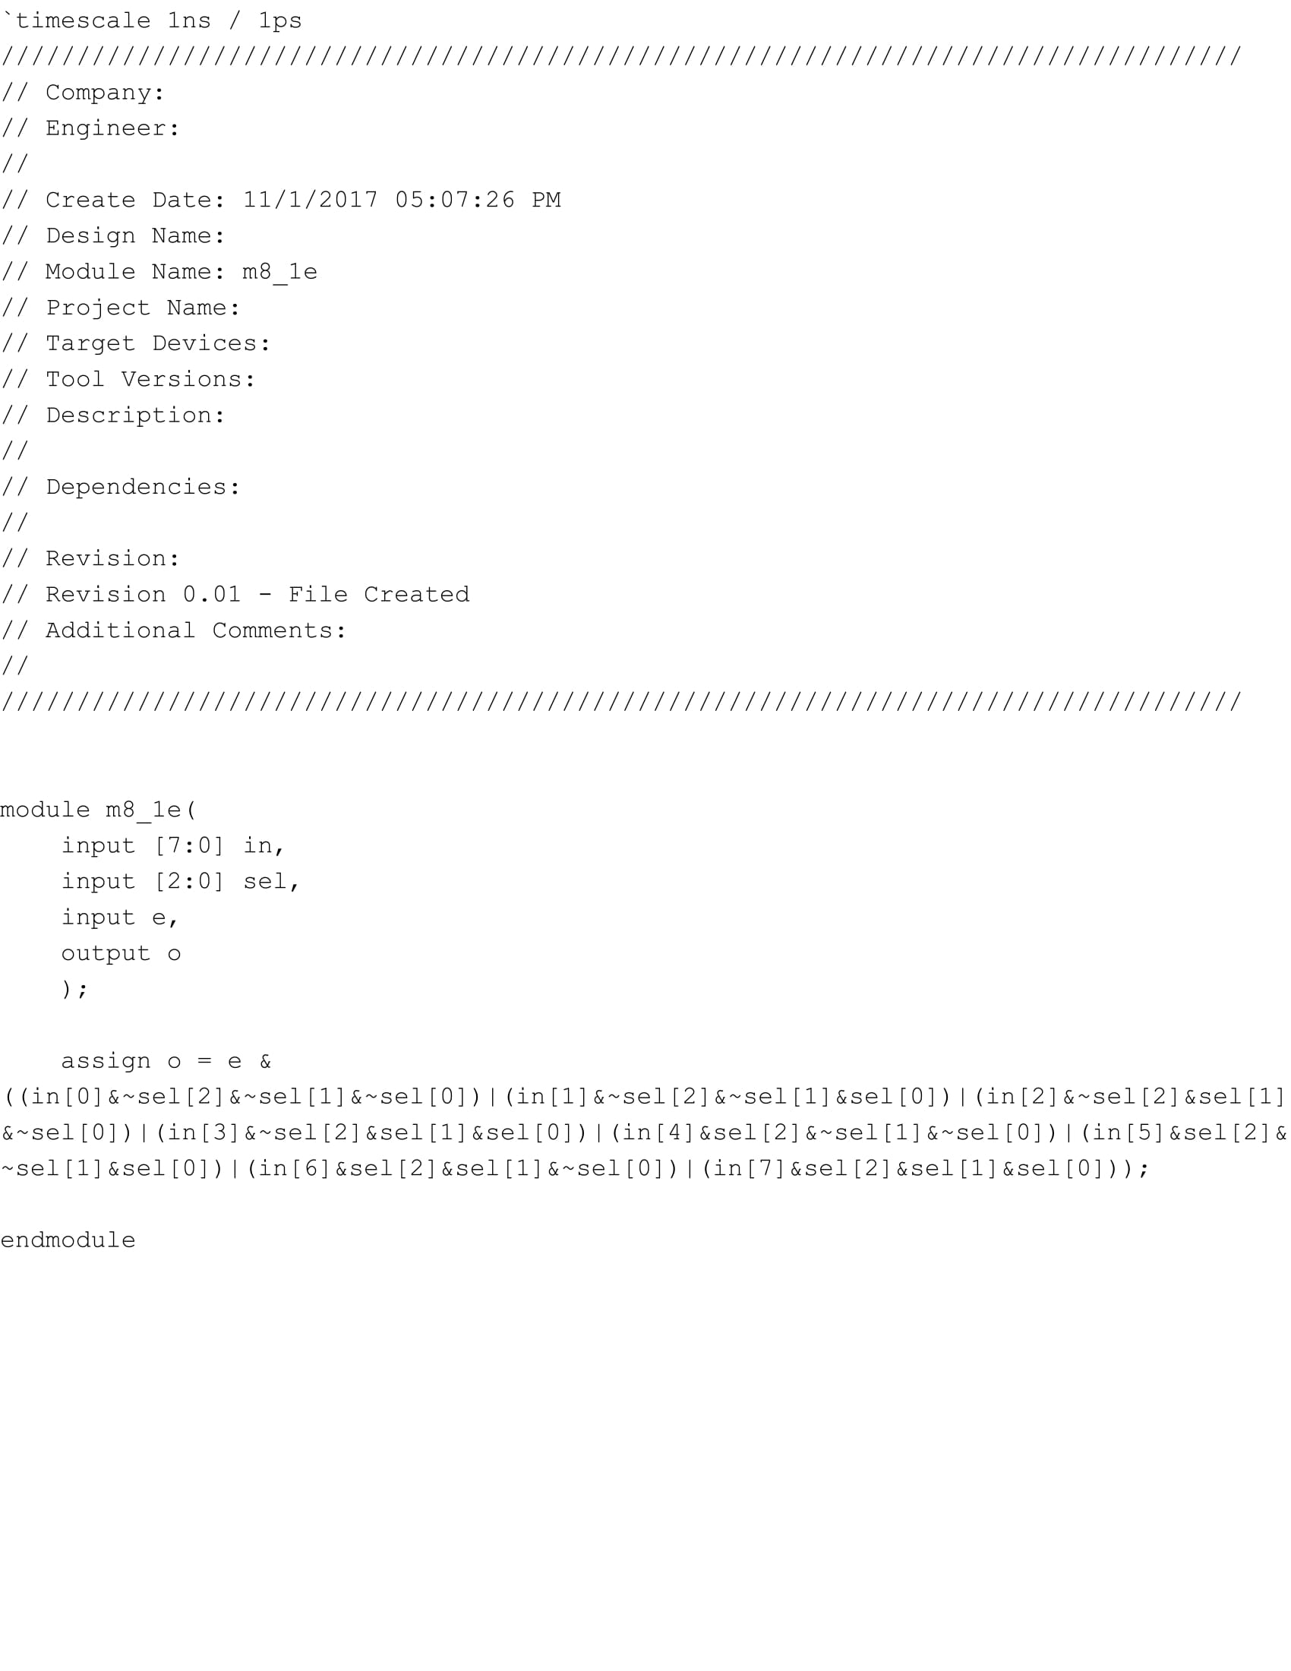

**Simulation Waveform:**

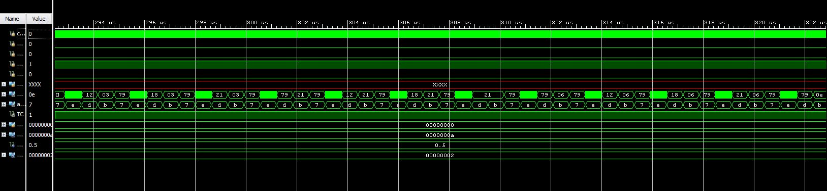

**Notebook Pages:**